Example test



| Date | Test number | Purpose | How test is done | Expected results | Actual Results | Next step |
| --- | --- | --- | --- | --- | --- | --- |
| The date of the test being done | (#) The number of the test being done | Why the test is being done, what the test needs to accomplish | Step-by-step of how the test was done | The ideal scenario where the test is successful with no bugs and no logic errors | **SUCCESS/FAIL**, The actual result of the test | What my next goal with the program is, or what I am planning on testing next. |

Testing

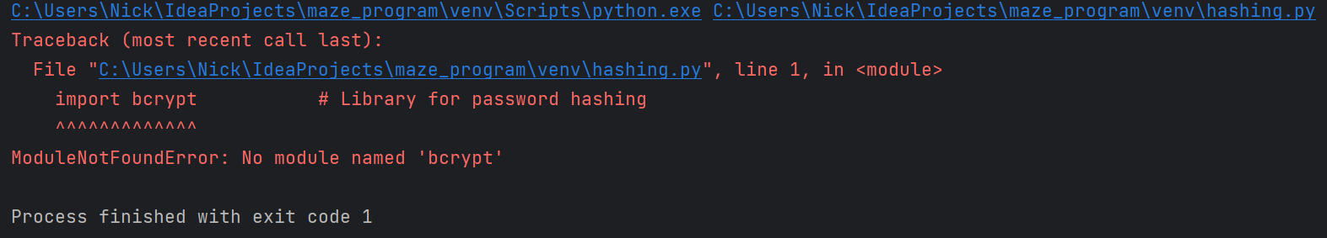

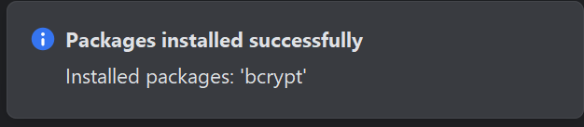

| Date | Test number | Purpose | How test is done | Expected results | Actual results | Next step |
| --- | --- | --- | --- | --- | --- | --- |
| Sep 4, 2023 | 1 | To test if the program runs | Running the program | The program displays a main menu, with 3 buttons: “Generate maze”, “My mazes” and “Quit” | **FAIL**. Returns an error, the bcrypt module is not installed. (Library to aid with password hashing) | Install the bcrypt library |

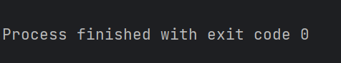

| Date | Test number | Purpose | How test is done | Expected results | Actual results | Next step |
| --- | --- | --- | --- | --- | --- | --- |
| Sep 5, 2023 | 2 | To test if the program runs | Running the program | The program displays a main menu, with 3 buttons: “Generate maze”, “My mazes” and “Quit” | **SUCCESS** The program runs. No error appears, however the program instantly stops running as well. | Implement the basics of a maze generation algorithm that will generate an empty canvas (10px by 10px empty rectangle) |



| Date | Test number | Purpose | How test is done | Expected results | Actual results | Next step |
| --- | --- | --- | --- | --- | --- | --- |
| Sep 5, 2023 | 3 | To see if the program will run and display elements and to see if a 10x10 rectangle is created | Running the program | The program runs as expected and I am able to create a 10x10 rectangle | **FAIL** The program runs, but instantly stops. No error appears, but that isn’t necessarily helpful. | Initiate the tkinter GUI and other parts of the program, by calling the main_menu() to start the tkinter GUI and by definition the entire program |

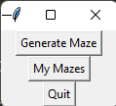

| Date | Test number | Purpose | How test is done | Expected results | Actual results | Next step |
| --- | --- | --- | --- | --- | --- | --- |
| Sep 5, 2023 | 4 | To see if the main_menu() function is correctly called and its elements are displayed (generate maze, my mazes, quit ) buttons | Running the program | The program runs as expected and I can see the three buttons | **SUCCESS** The buttons are successfully displayed on the tkinter canvas | Test if the generate_maze_menu works |

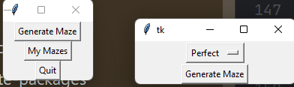

| Date | Test number | Purpose | How test is done | Expected results | Actual results | Next step |
| --- | --- | --- | --- | --- | --- | --- |
| Sep 6, 2023 | 5 | To see if clicking on the generate maze button successfully calls the generate_maze_menu function | Running the program → Clicking on “generate maze” button | The program calls the generate_maze_menu method, which displays two buttons: “Perfect” and “Generate maze” | **SUCCESS**The generate_maze_menu method is successfully called which displays the “Perfect” and “Generate maze” buttons | Test if the dropdown choice menu between Perfect and Non-Perfect successfully works and I am able to change it from Perfect to Non-perfect and back |

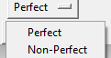

| Date | Test number | Purpose | How test is done | Expected results | Actual results | Next step |
| --- | --- | --- | --- | --- | --- | --- |
| Sep 6, 2023 | 6 | Test if the dropdown choice menu between Perfect and Non-Perfect successfully works and I am able to change it from Perfect to Non-perfect and back | Clicking on “perfect” and choosing “non-perfect” | This should open a dropdown menu where the user can choose between perfect and non-perfect. | **SUCCESS**. Opens a dropdown menu where the user can choose between perfect and non-perfect | Test if the generate maze button correctly generates a 10x10 canvas |

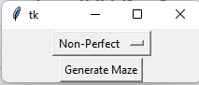

| Date | Test number | Purpose | How test is done | Expected results | Actual results | Next step |
| --- | --- | --- | --- | --- | --- | --- |
| Sep 6, 2023 | 7 | Test if the generate maze button correctly generates a 10x10 canvas | Running the program → Generate maze → Click on the generate maze button | The button should generate a 10x10 rectangle | **FAIL**. The button doesn’t do anything | Test if the “my mazes” button in the main menu doesn’t crash when clicked |

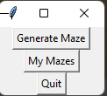

| Date | Test number | Purpose | How test is done | Expected results | Actual results | Next step |
| --- | --- | --- | --- | --- | --- | --- |
| 7 Sept 2023 | 8 | Test if the “my mazes” button in the main menu doesn’t crash when clicked | Running the program → Click on the “my mazes” button in the main menu | The program should not crash. Also nothing should happen as I haven’t attached any event to the button. | **SUCCESS**. The program doesn’t crash when the button is clicked. | Test if the “quit” button successfully works and halts the program. |



| Date | Test number | Purpose | How test is done | Expected results | Actual results | Next step |
| --- | --- | --- | --- | --- | --- | --- |
| 8 Sept 2023 | 9 | Test if the “quit” button successfully works and halts the program. | Running the program → Click on the “quit” button in the main menu | The program should finish halt | **SUCCESS**. The program halts. | Increase the size of the program’swindow |

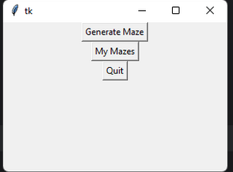

| Date | Test number | Purpose | How test is done | Expected results | Actual results | Next step |
| --- | --- | --- | --- | --- | --- | --- |
| 10 Sept 2023 | 10 | Test if the window size has increased | Run the program | The window size should have increased | **SUCCESS**. The window got larger | Implement a basic algorithm that would generate an empty, 10x10 (white) canvas when the “Generate maze” button is clicked |

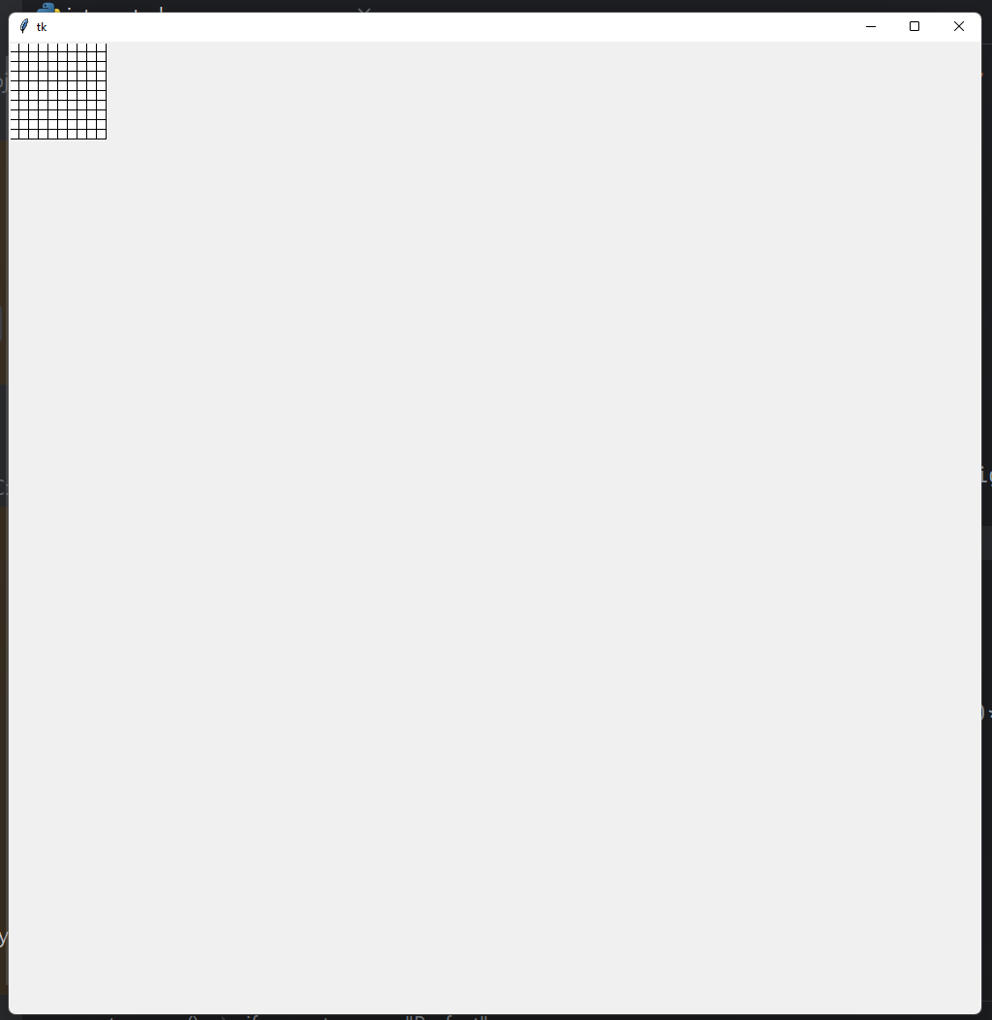

| Date | Test number | Purpose | How test is done | Expected results | Actual results | Next step |
| --- | --- | --- | --- | --- | --- | --- |
| 12 Sept 2023 | 11 | Test the “Generate maze” button to see if it correctly outputs a 10x10 empty canvas | Running the program → Make maze → Click on the generate maze button | A 10x10 rectangle should appear, with 100 cells in it | **SUCCESS**. The 10x10 rectangle appears and all the cells are empty (white) | Change the name of the “generatemaze” button in the main menu to “Make maze” to avoid confusion |

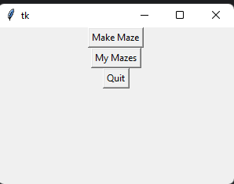

| Date | Test number | Purpose | How test is done | Expected results | Actual results | Next step |
| --- | --- | --- | --- | --- | --- | --- |
| 13 Sept 2023 | 12 | Test the text of the “Generate maze” button in the main menu has changed to “Make maze” | Run the program and look at the main menu | The text should have changed to “Make maze” | **SUCCESS**. The text has changed. | Stop the program from opening in a new window every time I press a button. |

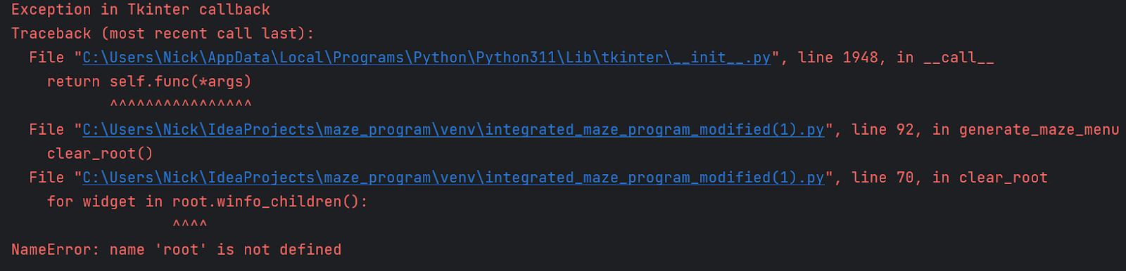

| Date | Test number | Purpose | How test is done | Expected results | Actual results | Next step |
| --- | --- | --- | --- | --- | --- | --- |
| 15 Sept 2023 | 13 | Test if the program deletes everything in the canvas when I click on “Make maze” button | Run the program, then click on “make maze” | Everything should be deleted from the main window (all the widgets) | **FAIL**. The program returns an NameError when I try to run it | Fix the NameError and have the program correctly start with no error |

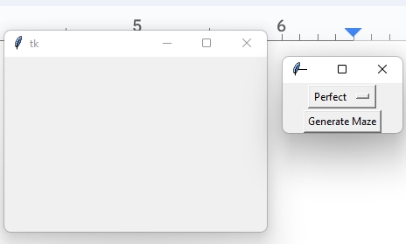

| Date | Test number | Purpose | How test is done | Expected results | Actual results | Next step |
| --- | --- | --- | --- | --- | --- | --- |
| 19 Sept 2023 | 14 | Test if the error has been fixed, and the program runs. It should remove all widgets from the main window when I click on “Make maze” | Run the program, then click on “make maze” | The program should start with no error. Everything should be deleted from the main window (all the buttons) when I click “make maze” | **SUCCESS**. The program no longer returns NameError and successfully starts. It also deletes every widget from the canvas when I click “Make maze” | Reuse the original window instead of creating a new window when clicking on “Make maze” button |

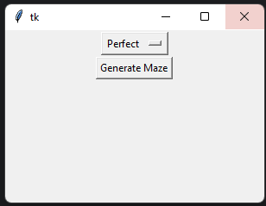

| Date | Test number | Purpose | How test is done | Expected results | Actual results | Next step |
| --- | --- | --- | --- | --- | --- | --- |
| 21 Sept 2023 | 15 | Test if a new window is no longer opened when I click “Make maze” and instead the contents are displayed in the current window. | Run the program, click on “Make maze” | All the widgets of the main window should be replaced with the new widgets of the “make maze menu” | **SUCCESS**. The program deletes all widgets of main_menu() and then creates all widgets from make_maze_menu() when I click on “Make maze” | Test if a new window is opened when I click on “generate maze” |

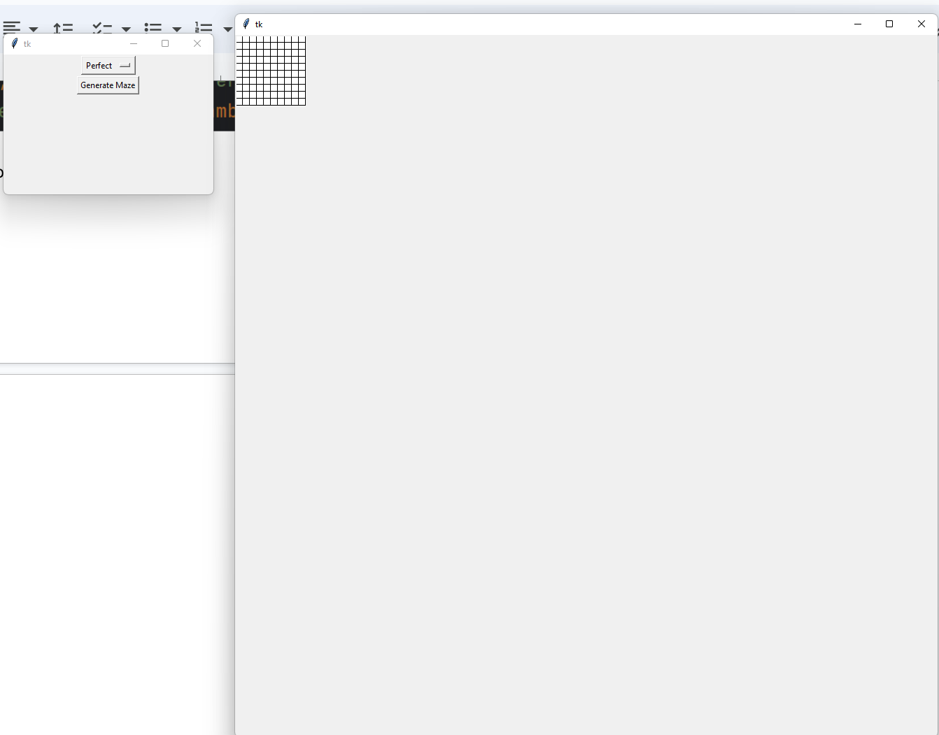

| Date | Test number | Purpose | How test is done | Expected results | Actual results | Next step |
| --- | --- | --- | --- | --- | --- | --- |
| 23 Sept 2023 | 16 | Test if a new window is opened when I click “Generate maze” and instead the contents are displayed in the current window. | Run the program, click on “Make maze” then click on “Generate maze” | A new window will open when I click on “Generate maze” | **SUCCESS**As expected. When I click “Generate maze” the ‘maze’ aka 10x10 empty canvas opens in a new window, which is not ideal. | Stop new window from being created when I click on “Generate maze” |

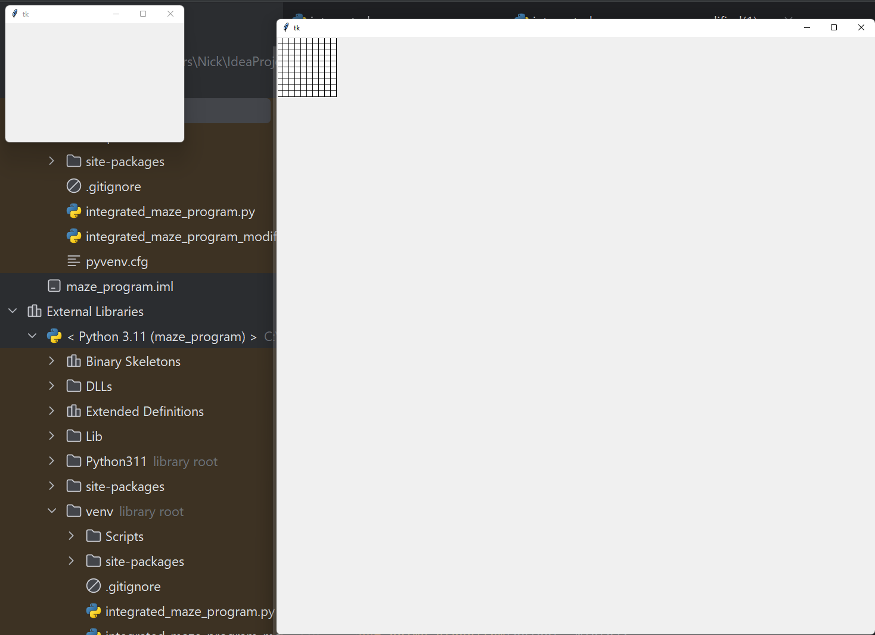

| Date | Test number | Purpose | How test is done | Expected results | Actual results | Next step |
| --- | --- | --- | --- | --- | --- | --- |
| 26 Sept 2023 | 17 | Test if the make_maze_menu successfully clears the window of all widgets when I click on “Generate Maze” | Running the program → Click on “Make Maze” → Click on “Generate maze” | A new window should open up that has the “maze” and the make_maze_menu should have nothing in it | **SUCCESS**As expected, a new window opens up that has the “maze” and the make_maze_menu has nothing in it | Stop a new window from being created when I click on “Generate maze”, and instead have the contents be displayed in the initial window |

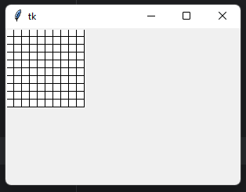

| Date | Test number | Purpose | How test is done | Expected results | Actual results | Next step |
| --- | --- | --- | --- | --- | --- | --- |
| 26 Sept 2023 | 18 | See if a new window is no longer created when I click on “Generate maze” | Click on “Generate maze” | A new window is not created. the contents of make_maze_menu are destroyed and replaced with the maze | **SUCCESS**As expected, a new window is not created. the contents of make_maze_menu are destroyed and replaced with the maze | To place the maze in the centre of the window instead of it being anchored to the top left corner |

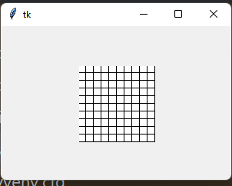

| Date | Test number | Purpose | How test is done | Expected results | Actual results | Next step |
| --- | --- | --- | --- | --- | --- | --- |
| 26 Sept 2023 | 19 | Test if the maze is now centred | Running the program → Make maze → Clicking on “Generate maze” button | The maze should appear in the centre now, and it should not be in the top left corner | **SUCCESS**As expected the maze now appears in the centre, and it is not in the top left corner | To change the title of the window to “Maze Program” from the default “tk” to give better context of the program |

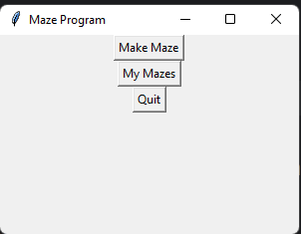

| Date | Test number | Purpose | How test is done | Expected results | Actual results | Next step |
| --- | --- | --- | --- | --- | --- | --- |
| 27 Sept 2023 | 20 | To see if the title of the program has been changed from “tk” to “Maze Program” | Running the program | The window should have changed to “Maze Program” | **SUCCESS**As expected the window has changed to “Maze Program” | Implement the maze generation algorithm “Prim’s Algorithm” to generate the actual maze and display it to the user |

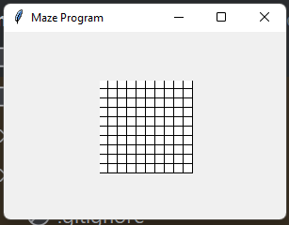

| Date | Test number | Purpose | How test is done | Expected results | Actual results | Next step |
| --- | --- | --- | --- | --- | --- | --- |
| 27 Sept 2023 | 21 | Test if the maze generation correctly works and displays to the user | Clicking on “Generate Maze” button | The maze should correctly generate using prim’s algorithm and display to the user | **FAIL** The maze doesn’t generate, instead a blank canvas still remains. | Debug why the maze generation and display failed, and fix these errors |



| Date | Test number | Purpose | How test is done | Expected results | Actual results | Next step |
| --- | --- | --- | --- | --- | --- | --- |
| 27 Sept 2023 | 22 | To debug the maze being fully empty and not displaying the paths to the user. My initial thinking is that the maze is correctly generated, but the displaying functionality fails for some reason | Clicking on “Generate Maze” after I added the debugging print statement in the program’s code | The program output the full layout of the maze in text format, with paths being represented by 1 and walls being represented by 0 | **FAIL** As it turns out, the maze is correctly displayed. However, the maze generation fails as it generates all paths | Re-write prim’s algorithm completely in hopes of fixing the error |

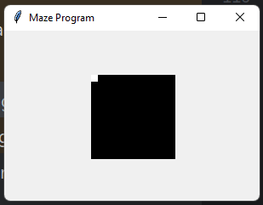

| Date | Test number | Purpose | How test is done | Expected results | Actual results | Next step |
| --- | --- | --- | --- | --- | --- | --- |
| 3 Oct 2023 | 23 | Test if the maze generation algorithm works now and the maze successfully generates and is displayed to the user | Running the program and then clicking on “Make Maze “ button, then generating the maze by clicking on “Generate Maze” button | The maze should have been generated and displayed to the user using Prim’s algorithm | **FAIL** A completely black canvas with all walls, with the exception of the top left cell being a pathway (white) | Debug the error in prim’s algorithm implementation and implement the changes for it to correctly generate the maze |

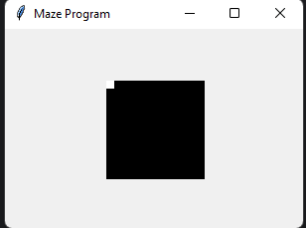

| Date | Test number | Purpose | How test is done | Expected results | Actual results | Next step |
| --- | --- | --- | --- | --- | --- | --- |
| 4 Oct 2023 | 24 | Test if the maze generation algorithm works now and the maze successfully generates and is displayed to the user | Running the program and then clicking on “Make Maze “ button, then generating the maze by clicking on “Generate Maze” button | The maze should have been generated and displayed to the user using Prim’s algorithm | **FAIL** A completely black canvas with all walls, with the exception of the top left cell being a pathway (white) | Check if the generate_maze function is called to make sure that the algorithm is actually used |



| Date | Test number | Purpose | How test is done | Expected results | Actual results | Next step |
| --- | --- | --- | --- | --- | --- | --- |
| 4 Oct 2023 | 25 | Check if the generate_maze function is called | When the generate maze function is called, added a print statement in the code to print “generate_maze called”. Run the program, click on “make maze” then click on “generate maze” to run the algorithm | The program should print out “generate_maze called” | **SUCCESS**. The program printed out “generate_maze_called” | Update my code so that it prints the maze after the function prims_algorthim to help me understand the issue better |

Output:   
[[1, 0, 0, 0, 0, 0, 0, 0, 0, 0], [0, 0, 0, 0, 0, 0, 0, 0, 0, 0], [0, 0, 0, 0, 0, 0, 0, 0, 0, 0], [0, 0, 0, 0, 0, 0, 0, 0, 0, 0], [0, 0, 0, 0, 0, 0, 0, 0, 0, 0], [0, 0, 0, 0, 0, 0, 0, 0, 0, 0], [0, 0, 0, 0, 0, 0, 0, 0, 0, 0], [0, 0, 0, 0, 0, 0, 0, 0, 0, 0], [0, 0, 0, 0, 0, 0, 0, 0, 0, 0], [0, 0, 0, 0, 0, 0, 0, 0, 0, 0]]

| Date | Test number | Purpose | How test is done | Expected results | Actual results | Next step |
| --- | --- | --- | --- | --- | --- | --- |
| 4 Oct 2023 | 26 | See the output and verify that the maze is being generated as expected | Running the program, clicking on “make maze” then clicking on “generate maze” | The program should output the maze exactly as it appears on the screen, it should output a list of 10 lists, Every sub-list will have 10 elements, which should all be 0 (for wall), the very first list should have 10 elements aswell, the first element should be 1 (path), the other 9 elements should be 0 | **SUCCESS**, the program outputs the maze as being fully black except the first cell which is the path | Clean up my code by deleting unnecessary parts, such as the currently unused login functionality, which I will re-implement at a later stage |

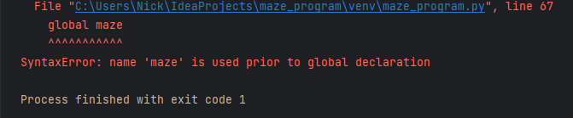

| Date | Test number | Purpose | How test is done | Expected results | Actual results | Next step |
| --- | --- | --- | --- | --- | --- | --- |
| 5 Oct 2023 | 27 | Test if the program runs correctly after I deleted some parts of my code | Running the program | The program should run correctly | **FAIL** SyntaxError: name ‘maze’ is used prior to global declaration | Update global maze directly instead of declaring a new local maze |

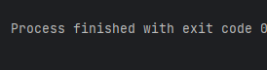

| Date | Test number | Purpose | How test is done | Expected results | Actual results | Next step |
| --- | --- | --- | --- | --- | --- | --- |
| 5 Oct 2023 | 28 | To test if the SyntaxError has disappeared and the program runs correctly | Running the program and checking for errors | The program should run correctly, it should not enter an infinite loop and should not crash. | **FAIL** The monitor freezes and the program enters an infinite while loop | Attempt to fix the freezing issue by fixing the infinite loop by debugging it by adding print statements throughout the loop |

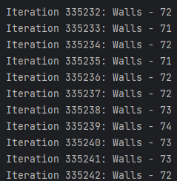

| Date | Test number | Purpose | How test is done | Expected results | Actual results | Next step |
| --- | --- | --- | --- | --- | --- | --- |
| 6 Oct 2023 | 29 | To debug the program with print statements at key logic points in the while loop, so I can see where the error lies | Adding print statements throughout the loop, The print statement I added will tell me the current iteration count and the wall the algorithm is on. | The program should output details about its loop which could potentially help me resolve the problem | **FAIL.** The program is stuck in a loop as it is outputting millions of lines like “Iteration 342535: Walls - 72” and going back and forth. It isn’t marking the newly added walls as visited, causing them to be revisited and therefore causing an infinite loop | Fix the error and test if the prim’s algorithm is correctly run as well as the display maze functionality that prints the maze on the canvas for the user to see. |

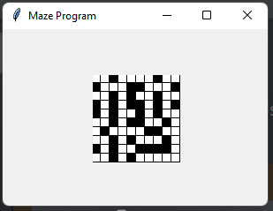

| Date | Test number | Purpose | How test is done | Expected results | Actual results | Next step |
| --- | --- | --- | --- | --- | --- | --- |
| 6 Oct 2023 | 30 | To test if the maze generation algorithm works and correctly displayed to the user | Running the program -> Make maze -> Generate maze | The program should generate a maze using prim’s algorithm and display it to the user | **SUCCESS**The program correctly does as expecting, generating a 10x10 maze | Test 5 different generations to make sure the program consistently generates the mazes |

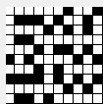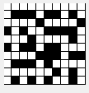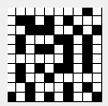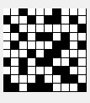

| Date | Test number | Purpose | How test is done | Expected results | Actual results | Next step |
| --- | --- | --- | --- | --- | --- | --- |
| 7 Oct 2023 | 31 | Test 5 different generations to make sure the program consistently generates the mazes | Generating the same maze 5 different times | All the mazes should be different, and the program shouldn’t crash. The mazes should follow the prims_algorithm logic | **SUCCESS**As expected, the 5 mazes generated look similar but none of them are alike, they are all different and the program doesn’t crash | Introduce an option to “Regenerate” the current maze with the same parameters (height and width values) |

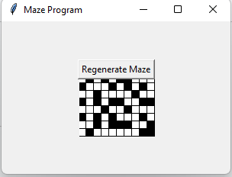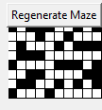

| Date | Test Number | Purpose | How test is done | Expected results | Actual results | Next step |
| --- | --- | --- | --- | --- | --- | --- |
| 7 Oct 2023 | 32 | Test if the regenerate maze button appears, and if it works correctly | When the maze has been created, click on the Regenerate Maze button | The generate maze button should appear above the maze and not obstruct it. When clicked on it, it should correctly re-generate the maze causing no errors and having the maze be re-created using prim’s algorithm to be a different maze | **FAIL** The regenerate button works as expected, however it obstructs the maze by being overlaid on top of it. | Implement changes to the code to have the button dynamically move depending on the size of the maze, and for the button to always be above the maze incase the user chooses to enter larger values for the size of the maze, the button should not obstruct the output |

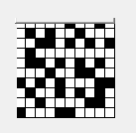

| Date | Test number | Purpose | How test is done | Expected results | Actual results | Next step |
| --- | --- | --- | --- | --- | --- | --- |
| 9 Oct 2023 | 33 | Test if the regenerate maze button has moved to no longer obstruct the current maze | Running the program -> make maze -> generate maze | The regenerate maze button should no longer obstruct the maze and be placed directly above it | **FAIL** The button is now cut off, only the bottom ~20% of the button is visible and it still very slightly obstructs the half of the top row of the cells of the maze | Pack the button and canvas into a frame and then place the frame on the root window to make sure both the button and canvas are part of the same container |

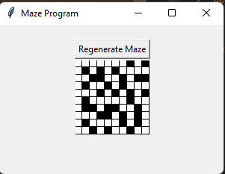

| Date | Test number | Purpose | How test is done | Expected results | Actual results | Next step |
| --- | --- | --- | --- | --- | --- | --- |
| 10 Oct 2023 | 34 | Test if the regenerate maze button has moved to no longer obstruct the current maze | Running the program -> make maze -> generate maze | The regenerate maze button should no longer obstruct the maze and be placed directly above it | **SUCCESS**As expected. The button no longer obstructs the maze and is placed directly above it, allowing both the button to be clicked and the maze to be fully viewed. | Add a “quit” button above the regenerate maze , that will also have dynamically updated position |

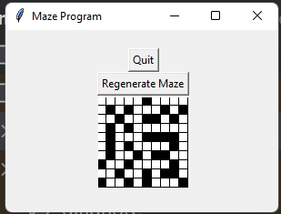

| Date | Test number | Purpose | How test is done | Expected results | Actual results | Next step |
| --- | --- | --- | --- | --- | --- | --- |
| 10 Oct 2023 | 35 | Test if the quit button was successfully added and is directly above the regenerate maze button. It should not obstruct the maze or the regenerate maze button | Running the program -> Make maze -> generate maze | The quit button should have been correctly placed above “Regenerate Maze” and it should work correctly, halting the program when clicked | **SUCCESS**As expected, the quit button does not interfere with the maze or the regenerate maze button | Create a slider to choose the size of the maze, height and width coordinates at the same time. The slider should be in the make maze menu |

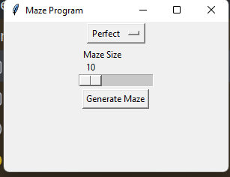

| Date | Test number | Purpose | How test is done | Expected results | Actual results | Next step |
| --- | --- | --- | --- | --- | --- | --- |
| 10 Oct 2023 | 36 | Test if the slider was implemented and correctly displayed in the make maze menu | Running the program -> Make maze -> Choosing different values for the slider | The slider should successfully appear and allow me to change the values on it (x and y) | **SUCCESS**The slider successfully appears as expected and lets me change the value on the slider | Test if the maze generation works with the slider being at different values, so differently sized mazes. |

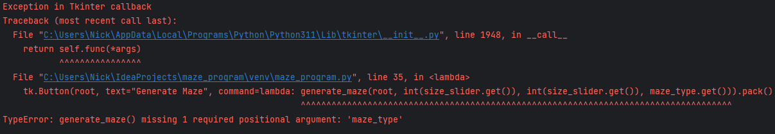

| Date | Test number | Purpose | How test is done | Expected results | Actual results | Next step |
| --- | --- | --- | --- | --- | --- | --- |
| 11 Oct 2023 | 37 | Test if the maze generation works with the slider being at different values, so differently sized mazes. | Running the program → Make maze → Choosing different values for the slider, → clicking on “Generate maze” | The maze should successfully generate with the given height and width | **FAIL** The program crashes when I try to generate the maze, giving a TypeError telling me that the generate_maze() function is missing 1 required positional argument (maze_type) | Pass the missing argument into the generate_maze function and hopefully the program stop crashing |

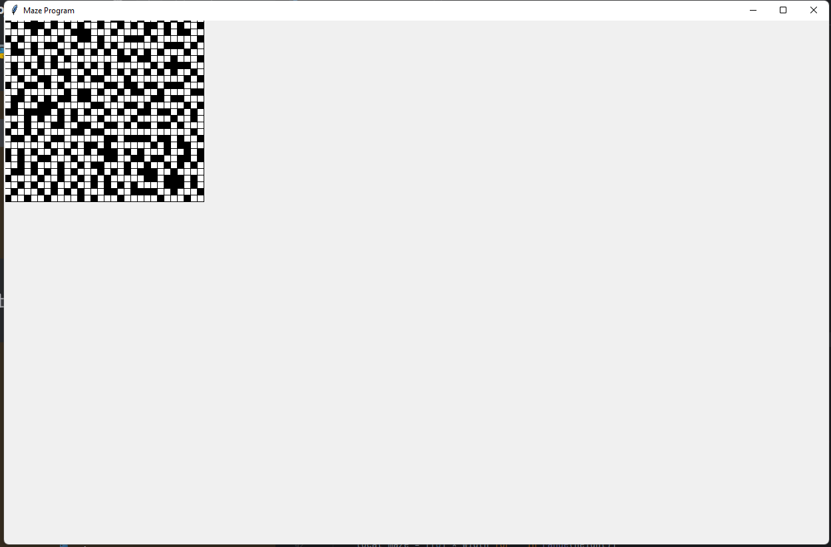

| Date | Test number | Purpose | How test is done | Expected results | Actual results | Next step |
| --- | --- | --- | --- | --- | --- | --- |
| 12 Oct 2023 | 38 | Test if the program now runs correctly, and also to test if the maze generation works with the slider being at different values, so differently sized mazes. | Running the program -> Make maze - > Choosing a value for the slider -> generate maze | The program shouldn’t crash anymore when I generate the maze. The maze should now be successfully generated given the height and width values chosen with the slider | **SUCCESS**As expected, however the maze is now in the top left corner and the “Regenerate maze” and “Quit” buttons are no longer visible | Test if a different size chosen for the slider will work and correctly generate the maze |

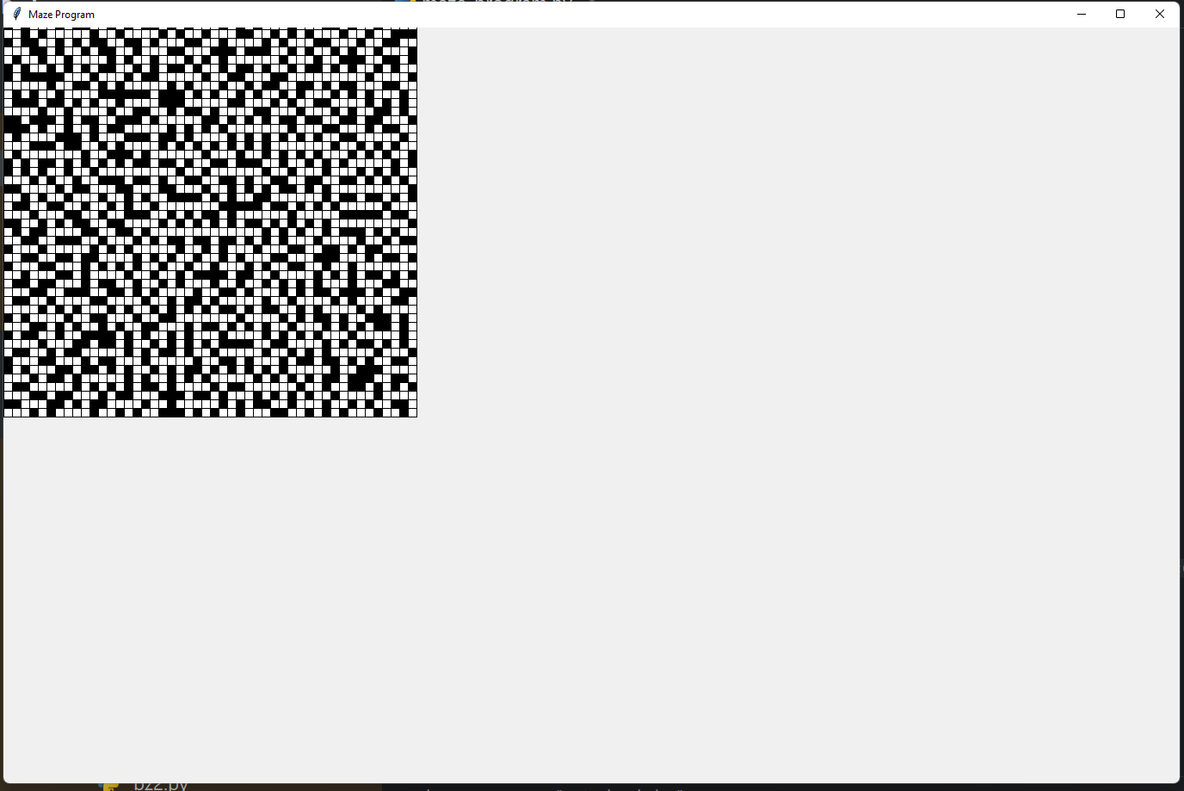

| Date | Test number | Purpose | How test is done | Expected results | Actual results | Next step |
| --- | --- | --- | --- | --- | --- | --- |
| 13 Oct 2023 | 39 | Choosing a different value for the slider (e.g. 60x60 instead of 40x40) now to see if the maze is still correctly generates | Run program -> Make maze -> Choose value for the slider -> Generate maze | The maze will most likely generate in the top left corner, obstructing the “regenerate maze” and the “quit” buttons but it should be bigger now | **FAIL** As expected, the maze is successfully generated using prim’s algorithm but the layout is flawed as it obstructs two buttons | Fix the maze generating in the top left corner, instead it should generate in the middle without obstructing any of the buttons |

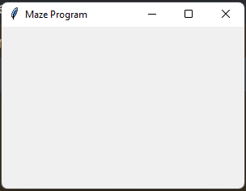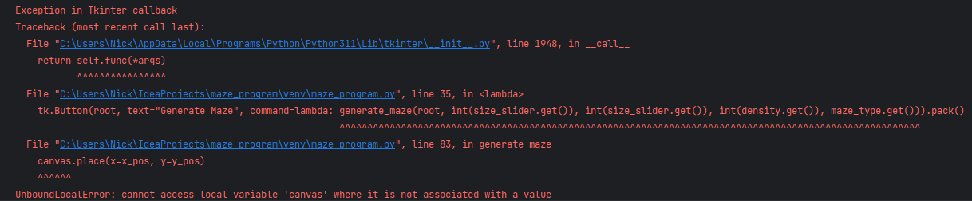

| Date | Test number | Purpose | How test is done | Expected results | Actual results | Next step |
| --- | --- | --- | --- | --- | --- | --- |
| 17 Oct 2023 | 40 | See if the maze generating in the top left corner has been fixed. It should generate in the middle now | Run program -> make maze -> choose values for height, width on the slider -> Generate maze | the maze should now be in the centre | **FAIL** The maze does not appear at all anymore. Instead of being in the centre , it now gives an error “UnboundLocalError: cannot access local variable ‘canvas’ where it is not associated with a value” | The program is attempting to use canvas.place() before the canvas has been defined within the function, so I will try to fix this next. |

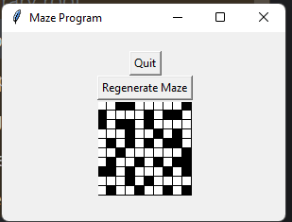

| Date | Test number | Purpose | How test is done | Expected results | Actual results | Next step |
| --- | --- | --- | --- | --- | --- | --- |
| 18 Oct 2023 | 41 | Test if the maze generation correctly works now. It should not obstruct the “Quit” or the “Regenerate Maze” buttons now and the maze should be generated in the centre | Running the program -> Make maze -> Choose values for height, width on the slider -> Generate maze | The maze should now generate in the centre and the “quit” and “regenerate maze” buttons should be directly above it | **SUCCESS**As expected, the program works now and does not give any errors. The maze now generates in the centre and the “quit” and “regenerate maze” buttons are directly above it | This was for a 10x10 maze. Next I will try generating mazes of larger height and width values. |

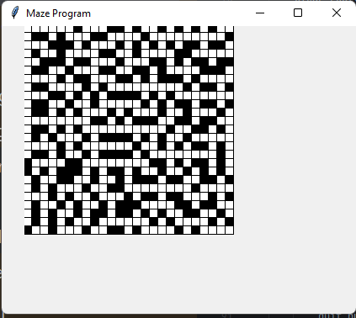

| Date | Test number | Purpose | How test is done | Expected results | Actual results | Next step |
| --- | --- | --- | --- | --- | --- | --- |
| 19 Oct 2023 | 42 | Test if the maze continues to be correctly laid out with the buttons for larger maze, e.g. 25x25 size | Running the program -> Make maze -> choosing values for height,width -> generate maze | The maze should be correctly aligned in the centre , just bigger now. It should be correctly generated using prim’s algorithm with the “regenerate” and “quit” buttons being above it | **FAIL** The maze no longer generates in the middle, and it now obstructs the “regenerate” and “quit” buttons | Attempt to fix this error by resizing the main window based on the canvas size of the maze |

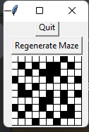

| Date | Test number | Purpose | How test is done | Expected results | Actual results | Next step |
| --- | --- | --- | --- | --- | --- | --- |
| 23 Oct 2023 | 43 | Test maze generation and layout for maze of size 10x10 | Run program -> Make maze -> Choose 10x10 on the slider -> Generate maze | The maze should be successfully generated now with the “Quit” and “Regenerate maze” buttons not being obstructed by the canvas. | **SUCCESS**As expected, this maze generation test has passed and it has generated correctly, with the proper layout. | Test for 38x38 maze |

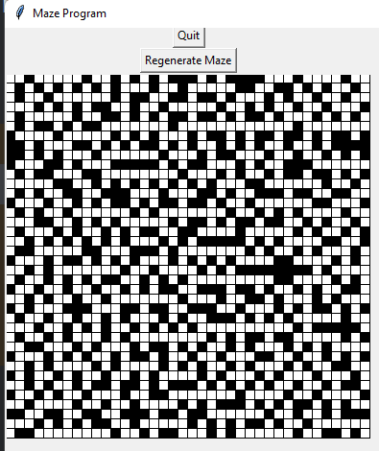

| Date | Test number | Purpose | How test is done | Expected results | Actual results | Next step |
| --- | --- | --- | --- | --- | --- | --- |
| 23 Oct 2023 | 44 | Test maze generation and layout for maze of size 38x38 | Run program -> Make maze -> Choose 38x38 on the slider -> Generate maze | The maze should be successfully generated now with the “Quit” and “Regenerate maze” buttons not being obstructed by the canvas. | **SUCCESS**As expected, this maze generation test has passed and it has generated correctly, with the proper layout. The maze is successfully generated now with the “Quit” and “Regenerate maze” buttons not being obstructed by the canvas. | Test for 100x100 maze |

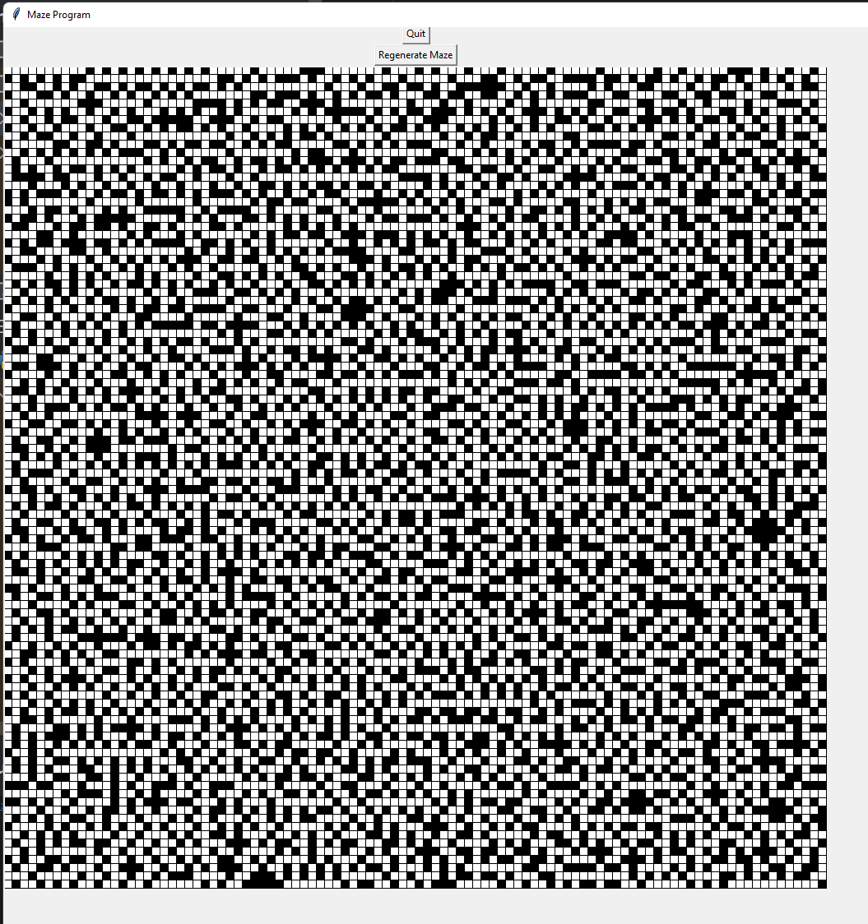

| Date | Test number | Purpose | How test is done | Expected results | Actual results | Next step |
| --- | --- | --- | --- | --- | --- | --- |
| 23 Oct 2023 | 45 | Test maze generation and layout for maze of size 100x100 | Run program -> Make maze -> Choose 100x100 on the slider -> Generate maze | The maze should be successfully generated now with the “Quit” and “Regenerate maze” buttons not being obstructed by the canvas. | **SUCCESS**As expected, the maze is successfully generated with the “Quit” and “Regenerate maze” buttons not being obstructed by the canvas. | Create a maze class with attributes for height and width and place several function in it that would call the algorithm to tidy up the program |

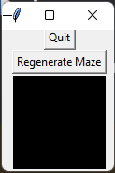

| Date | Test number | Purpose | How test is done | Expected results | Actual results | Next step |
| --- | --- | --- | --- | --- | --- | --- |
| 23 Oct 2023 | 46 | Test, after I have created the “Maze” class and moved some functions there, the program should still run as expected | Running the program -> make maze -> Generate maze | The program should still function correctly, but now when I click on “Non-perfect” maze, it should output a fully black canvas as there is no algorithm setup to generate a maze for that option | **SUCCESS**As expected, the full program works correctly. All the buttons and GUIs still work, and I am able to generate the maze as well. When I choose non-perfect, it generates a completely black canvas which is the expected outcome | Implement a “Go back” and “quit” buttons in the menus for easier navigation across the program |

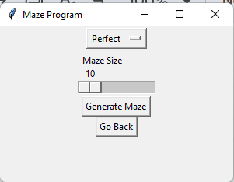

| Date | Test number | Purpose | How test is done | Expected results | Actual results | Next step |
| --- | --- | --- | --- | --- | --- | --- |
| 24 Oct 2023 | 47 | Test if there is a “go back” button in the make maze menu that allows the user to go back to the main menu | Run program -> Make maze → Go back | There should be a button in the menu that lets the user go back to the previous menu (main menu) | **SUCCESS**As expected, the button allows going back to the previous menu | Test if there is a “Go back” button in “My mazes” menu |

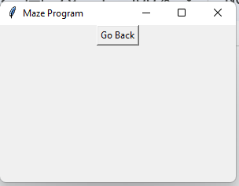

| Date | Test number | Purpose | How test is done | Expected results | Actual results | Next step |
| --- | --- | --- | --- | --- | --- | --- |
| 25 Oct 2023 | 48 | Test if there is a “Go back” button in the “my mazes” menu | Run program -> My mazes → Go back | There should appear a button that lets the user go back from My Mazes -> Main Menu | **SUCCESS**As expected, such button appears and works correctly | Test if the “Quit” and “Regenerate maze” buttons are correctly updated and aligned when the maze has been created |

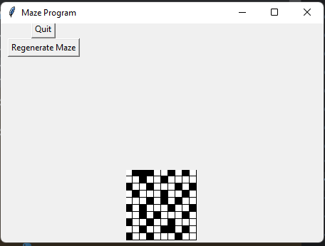

| Date | Test number | Purpose | How test is done | Expected results | Actual results | Next step |
| --- | --- | --- | --- | --- | --- | --- |
| 25 Oct 2023 | 49 | Test if the “Quit” and “Regenerate maze” buttons are correctly updated and aligned when the maze has been created | Run program -> Make maze -> Generate maze | The program should have the “quit” and “regenerate maze” buttons be directly above the maze | **FAIL** The maze is no longer centred in the middle, also the buttons are now aligned to the top left corner | Reposition the buttons to be in the correct place, above the maze. Also the maze should be in the centre |

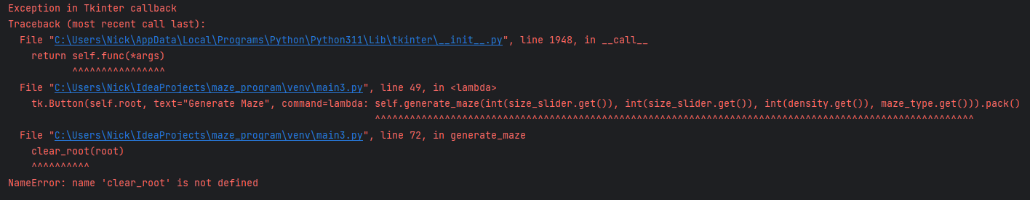

| Date | Test number | Purpose | How test is done | Expected results | Actual results | Next step |
| --- | --- | --- | --- | --- | --- | --- |
| 26 Oct 2023 | 50 | Test if the changes I had made to the code have fixed the issue of the text boxes being misaligned | Running the program -> make maze -> generate maze | The maze should now be in the centre and the two buttons “Regenerate Maze” and “Quit” should be directly above it | **FAIL** NameError: Name clear_root is not defined. Fail | Define the clear_root function in MazeApplication |

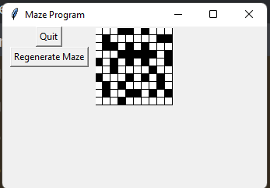

| Date | Test number | Purpose | How test is done | Expected results | Actual results | Next step |
| --- | --- | --- | --- | --- | --- | --- |
| 27 Oct 2023 | 51 | Test if the program is no longer crashing when I try to run it | Run the program | The program should run without error now. Also, the maze canvas should now be in the top-bottom and be fully visible, alongside the buttons. | **SUCCESS**The program runs as expected, The maze is aligned to the top right, and and the two buttons “Regenerate maze” and “Quit” are aligned to the left of the maze canvas | Add a go back button in the menu where the maze canvas is created |

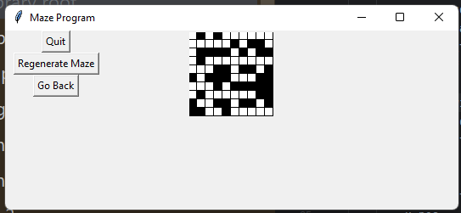

| Date | Test number | Purpose | How test is done | Expected results | Actual results | Next step |
| --- | --- | --- | --- | --- | --- | --- |
| 28 Oct 2023 | 52 | Test if the go back button now appears in the generate_maze menu | Run program -> Make maze -> Generate maze | There should be a “Go back” button below “Regenerate Maze” that will send the user back to the make_maze_menu | **SUCCESS**As expected, such button appears and the user can click on it with no error | Add a quit button in my mazes and make maze menus |

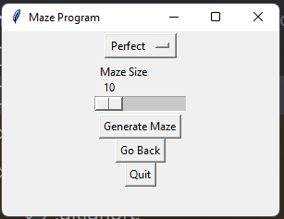

| Date | Test number | Purpose | How test is done | Expected results | Actual results | Next step |
| --- | --- | --- | --- | --- | --- | --- |
| 29 Oct 2023 | 53 | Test if the quit button now appears in the make_maze_menu | Run program -> Make maze | There should now be a button that lets the user halt the program at the bottom | **SUCCESS**Such button successfully appears, and pressing it will stop the program | Attempt to implement the recursive_backtracker algorithm for perfect maze generation |

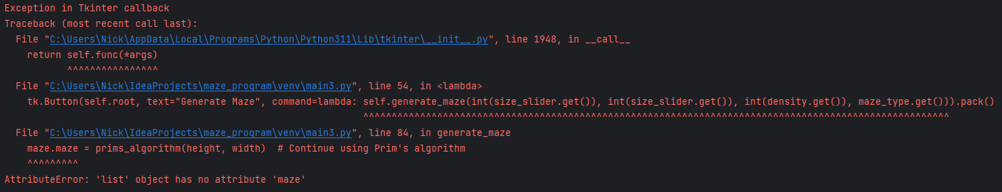

| Date | Test number | Purpose | How test is done | Expected results | Actual results | Next step |
| --- | --- | --- | --- | --- | --- | --- |
| 29 Oct 2023 | 54 | test if my recursive_backtracker function works as expected, and generates a blank canvas. The program shouldn’t crash | Running the program -> Make maze -> Generate maze | The program should run as expected and generate a blank canvas | **FAIL** The program crashes when I try to run it, giving an AttributeError | Fix the AttributeError by using self.maze within the generate_maze method to refer to the maze attribute of the maze class instance |

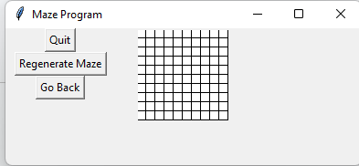

| Date | Test number | Purpose | How test is done | Expected results | Actual results | Next step |
| --- | --- | --- | --- | --- | --- | --- |
| 30 Oct 2023 | 55 | Test if selecting perfect maze outputs a blank canvas | Run program -> Make maze -> Perfect maze -> Generate maze | it should output a completely empty canvas | **SUCCESS**As expected, a completely 10x10 canvas is output | Test if using prim’s algorithm still works |

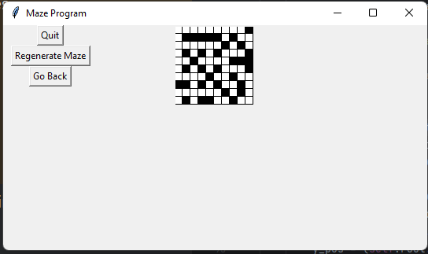

| Date | Test number | Purpose | How test is done | Expected results | Actual results | Next step |
| --- | --- | --- | --- | --- | --- | --- |
| 31 Oct 2023 | 56 | Test if using prim’s algorithm still works | Run program -> Make maze -> Generate maze | Should generate a maze using prim’s algorithm | **SUCCESS**Correctly uses prim’s algorithm to generate the maze, no errors given | Test if my recursive_backtracker algorithm for perfect maze generation still generates a blank canvas with larger maze |

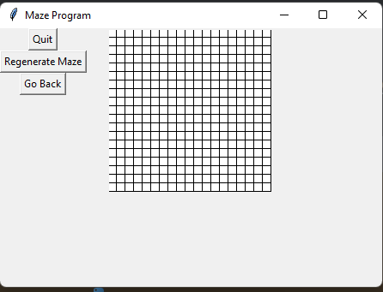

| Date | Test number | Purpose | How test is done | Expected results | Actual results | Next step |
| --- | --- | --- | --- | --- | --- | --- |
| 1 Nov 2023 | 57 | Test if my recursive_backtracker algorithm for perfect maze generation still generates a blank canvas with larger maze | Run program -> Make maze -> Choose a large canvas for example 60x60 | The entire maze should be empty just like the small maze | **SUCCESS**As expected, still the program outputs a blank canvas | Debug the recursive_backtracker function to find out the problem, why is it not generating a perfect maze |

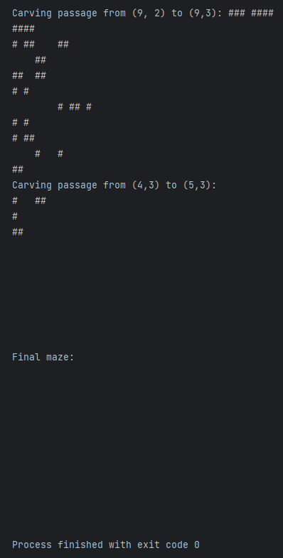

| Date | Test number | Purpose | How test is done | Expected results | Actual results | Next step |
| --- | --- | --- | --- | --- | --- | --- |
| 1 Nov 2023 | 58 | Debug the perfect maze generation algorithm and find out why it outputs a blank canvas | Added print statements throughout the algorithm that print the entire maze at various stages | It should print why the maze is fully blank and explain to me | **FAIL** The maze is filled in the beginning, then it is carved, but it seems the carving never stops. It just gets destroyed as time goes by | Fix the for loop that carves the walls in recursive_backtracker |

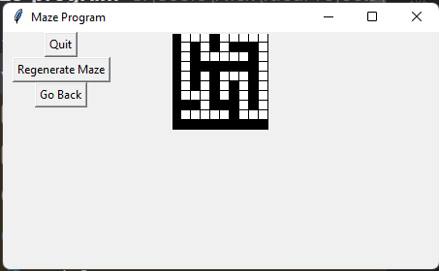

| Date | Test number | Purpose | How test is done | Expected results | Actual results | Next step |
| --- | --- | --- | --- | --- | --- | --- |
| 1 Nov 2023 | 59 | Test if the code correctly generates a perfect maze now that I have made changes to my code | Run program -> Make maze -> Perfect maze -> Generate maze | It should now output a perfect maze as expected, no longer white canvas | **SUCCESS**As expected, the issue has stopped and it now outputs the correct maze | Test if the recursive_backtracker for perfect maze generation still works with very large mazes |

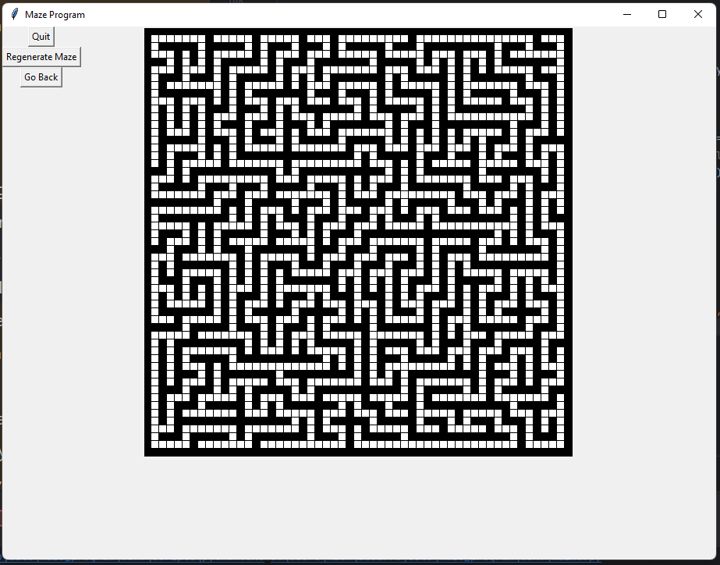

| Date | Test number | Purpose | How test is done | Expected results | Actual results | Next step |
| --- | --- | --- | --- | --- | --- | --- |
| 2 Nov 2023 | 60 | Test if the recursive_backtracker for perfect maze generation still works with very large mazes | Run program -> Make maze -> Perfect maze -> generate maze | It should correctly generate the maze despite being significantly larger now (100x100 maze) | **SUCCESS**The maze has been successfully generated | Add the A* Pathfinding algorithm to help find the path, then display the path. |

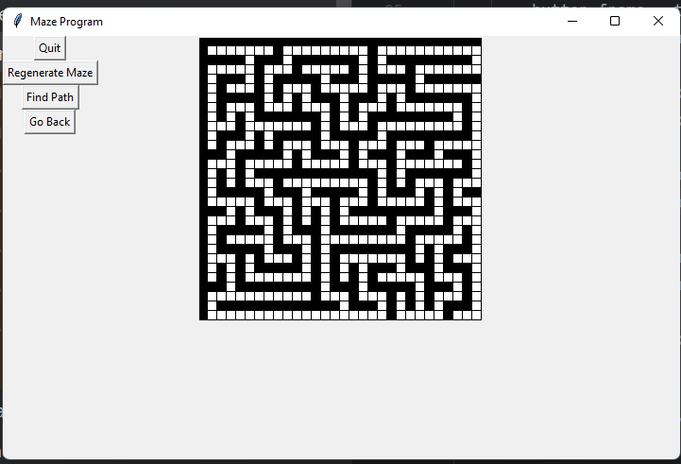

| Date | Test number | Purpose | How test is done | Expected results | Actual results | Next step |
| --- | --- | --- | --- | --- | --- | --- |
| 2 Nov 2023 | 61 | Test if the “Find path” button appears in the generate maze menu | Run program -> Make maze -> Perfect maze -> Generate maze -> Find path | The button should do nothing, but it should appear under “Regenerate Maze” and above “Go back” buttons | **SUCCESS**The button successfully appears and it doesn’t crash the program. The button does nothing as expected. | Implement A* search function and connect it to the “Find path” button |

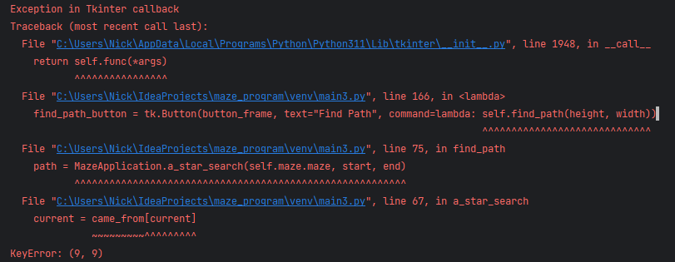

| Date | Test number | Purpose | How test is done | Expected results | Actual results | Next step |
| --- | --- | --- | --- | --- | --- | --- |
| 2 Nov 2023 | 62 | Test if the Find Path button works now, it should find the path and then display it to the user | Running program -> Make maze -> Perfect maze -> Generate maze -> Find path | The path should be found when I click on Find path. It should be displayed in blue. The path between the top right and the bottom left corners. | **FAIL** The program crashes when I attempt to start it. | Investigate why the program crashes and attempt to fix it |

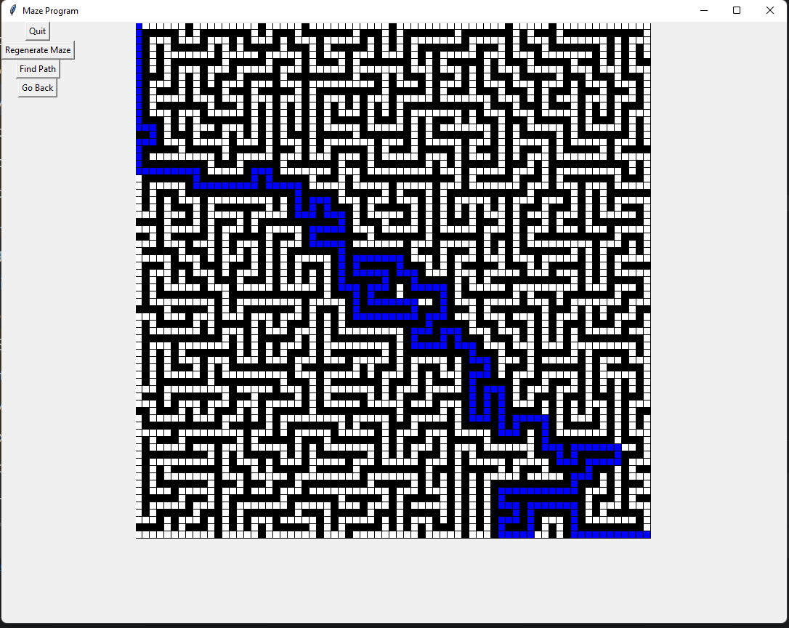

| Date | Test number | Purpose | How test is done | Expected results | Actual results | Next step |
| --- | --- | --- | --- | --- | --- | --- |
| 3 Nov 2023 | 63 | After making some changes to my code, test if the Find Path button works now, it should find the path and then display it to the user | Running program -> Make maze -> Perfect maze -> Generate maze -> Find path | The path should be found when I click on Find path. It should be displayed in blue. The path between the top right and the bottom left corners. | **SUCCESS**As expected, the path is found and then displayed on the screen in blue | Make the x and y coordinate a separate slider when generating the maze to allow for rectangular mazes |

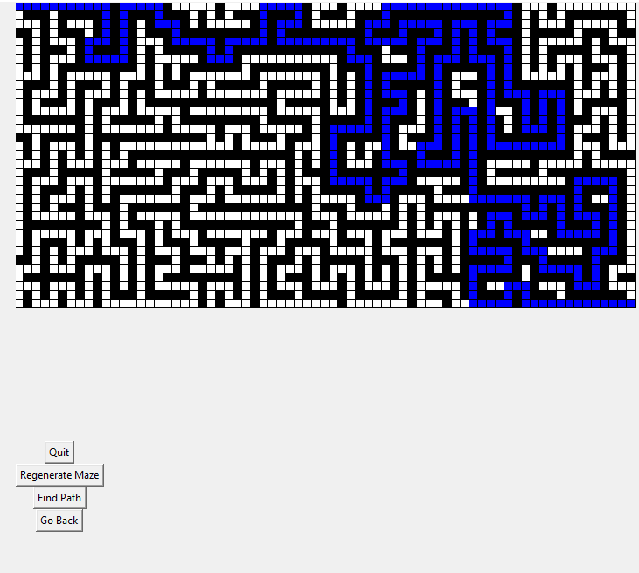

| Date | Test number | Purpose | How test is done | Expected results | Actual results | Next step |
| --- | --- | --- | --- | --- | --- | --- |
| 3 Nov 2023 | 64 | Test if the rectangle maze functionality works now | Run program -> Make maze -> Enter separate x and y coordinates -> Perfect maze -> generate maze | The program should have generated a rectangle maze as expected | **SUCCESS**The program correctly generated a maze that is 60 units wide and 20 units tall | Fix some mazes not having a path when being generated |

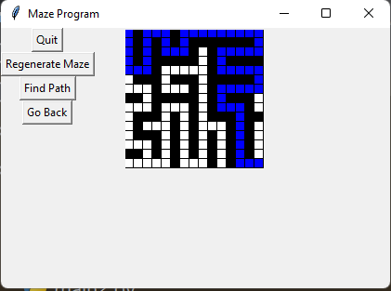

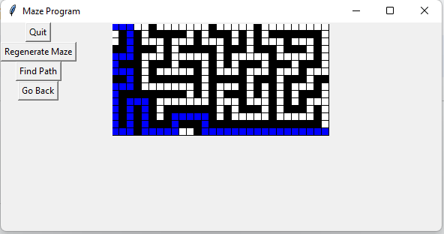

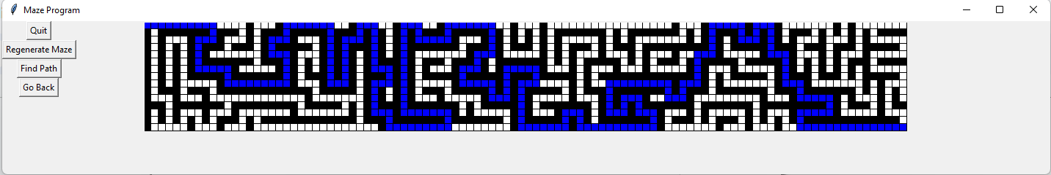

| Date | Test number | Purpose | How test is done | Expected results | Actual results | Next step |
| --- | --- | --- | --- | --- | --- | --- |
| 3 Nov 2023 | 65 | For various sizes (15x15, 15x39, 15x100) test if the maze is being generated with a path on the 1st attempt, and the program shouldn’t crash | Run program -> Make maze -> Enter different maze sizes -> Generate maze -> Find path | Each size of the mazes should be generated correctly. On the 1st attempt, and there should also be a solution that I can highlight with the “Find path” button | **SUCCESS**As expected, each maze has a solution and doesn’t crash, and appears rectangular with the exact dimensions that I specified. | Fix the “regenerate maze” button not doing anything. It should correctly regenerate the maze |

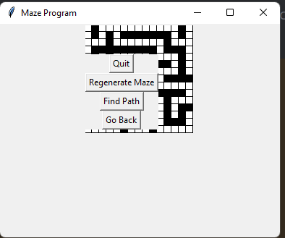

| Date | Test number | Purpose | How test is done | Expected results | Actual results | Next step |
| --- | --- | --- | --- | --- | --- | --- |
| 3 Nov 2023 | 66 | Test if the regenerate maze button successfully regenerates the maze | Run program -> Make maze -> Generate maze -> Regenerate maze | The regenerate maze button should now correctly regenerate the maze | **FAIL** Regenerate maze button works as expected. However, it is misaligned and blocks more than 60% of the maze | Reposition the buttons so they no longer block the maze |

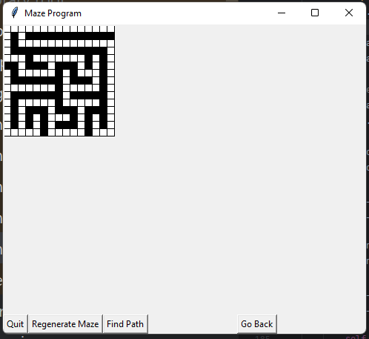

| Date | Test number | Purpose | How test is done | Expected results | Actual results | Next step |
| --- | --- | --- | --- | --- | --- | --- |
| 3 Nov 2023 | 67 | Test if the buttons have been repositioned correctly after I applied some changes to my code | Run program -> Make maze -> Generate maze | All the buttons now should directly at the bottom of the maze, they should no longer be blocked or block the maze itself. | **FAIL** The buttons no longer block the maze, and they are below the maze, however they aren’t aligned in a way I prefer. All of them hug the bottom wall and I would instead like them to directly be below the maze | Correctly align the buttons to be below the maze |

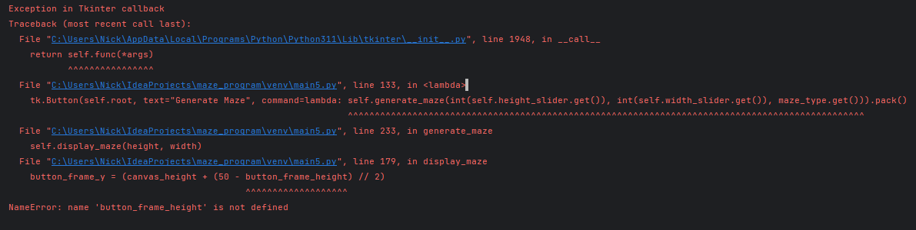

| Date | Test number | Purpose | How test is done | Expected results | Actual results | Next step |
| --- | --- | --- | --- | --- | --- | --- |
| 3 Nov 2023 | 68 | Test if the changes I had made to the code had fixed the buttons being misaligned | Run program -> Make maze -> Generate maze | All the buttons should directly be below the maze canvas now | **FAIL** The program crashes when I try to generate the maze, giving a NameError that button_frame_height is not defined | Attempt to fix the error by defining button_frame_height before it is used |

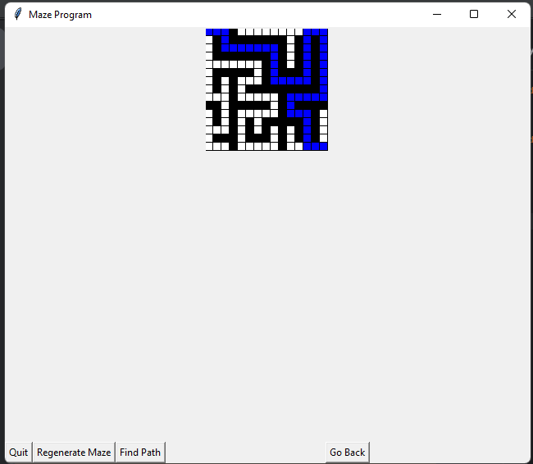

| Date | Test number | Purpose | How test is done | Expected results | Actual results | Next step |
| --- | --- | --- | --- | --- | --- | --- |
| 4 Nov 2023 | 69 | Test if the program now works and no longer crashes since I have defined button_frame_height | Run program -> Make maze -> generate maze | The program should no longer crash when I attempt to generate the maze | **FAIL** The program doesn’t crash anymore. however the issue with the buttons being misaligned still persists | The window button should not reset when I click “Regenerate maze” |

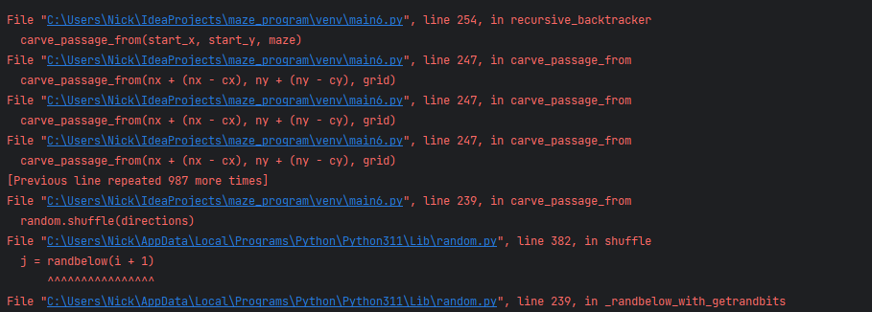

| Date | Test number | Purpose | How test is done | Expected results | Actual results | Next step |
| --- | --- | --- | --- | --- | --- | --- |
| 4 Nov 2023 | 70 | Test if my code works after I had made some changes to it. It should now run correctly and the window size should not reset when I click “regenerate maze” | Running the program -> Make maze -> generate maze -> regenerate maze | The window size should not be reset anymore | **FAIL** The program crashes now when I attempt to generate the maze | Investigate why the program crashes and fix the issue |

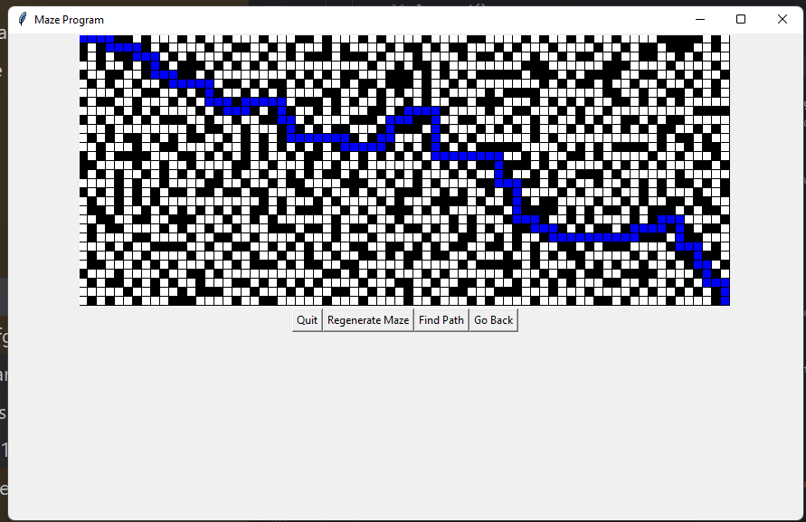

| Date | Test number | Purpose | How test is done | Expected results | Actual results | Next step |
| --- | --- | --- | --- | --- | --- | --- |
| 4 Nov 2023 | 71 | Test if the program has stopped crashing and if the path finding algorithm works with non-perfect mazes, mazes that use A* path finding | Running the program and generating the maze using non-perfect option, then clicking “Find path” | The program should not crash anymore. It should also correctly generate the maze with prim’s algorithm and find the path for it | **SUCCESS**Exactly as expected. I had fixed the issue earlier which caused my code to crash. Now it finds the path in the non-perfect maze successfully. | Test again if another maze created with prim’s algorithm will have a solution |

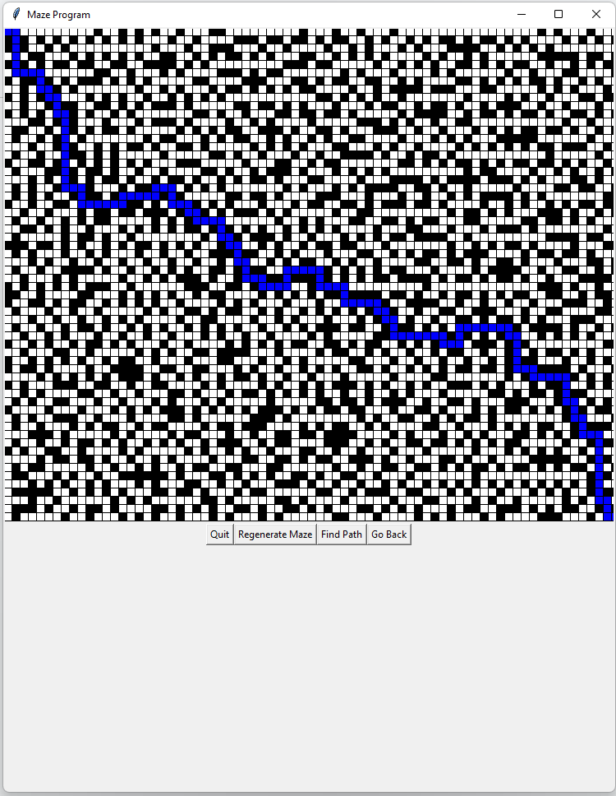

| Date | Test number | Purpose | How test is done | Expected results | Actual results | Next step |
| --- | --- | --- | --- | --- | --- | --- |
| 5 Nov 2023 | 72 | Test if another maze generated using prim’s algorithm (non-perfect) will have a solution | Clicking on the “Regenerate” button then “Find path” | It should regenerate the maze which would also have a path | **SUCCESS**As expected. The maze regenerates and the path is displayed correctly. | Implement a randomize button that will randomize the height and width of the maze |

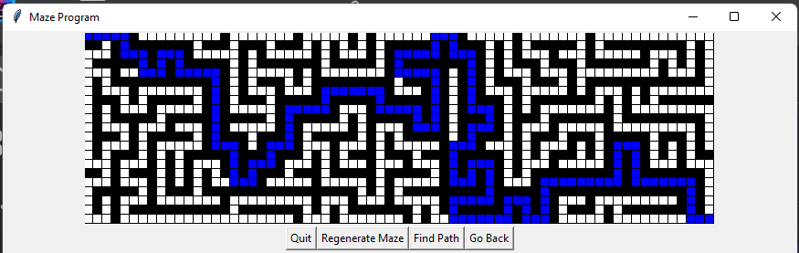

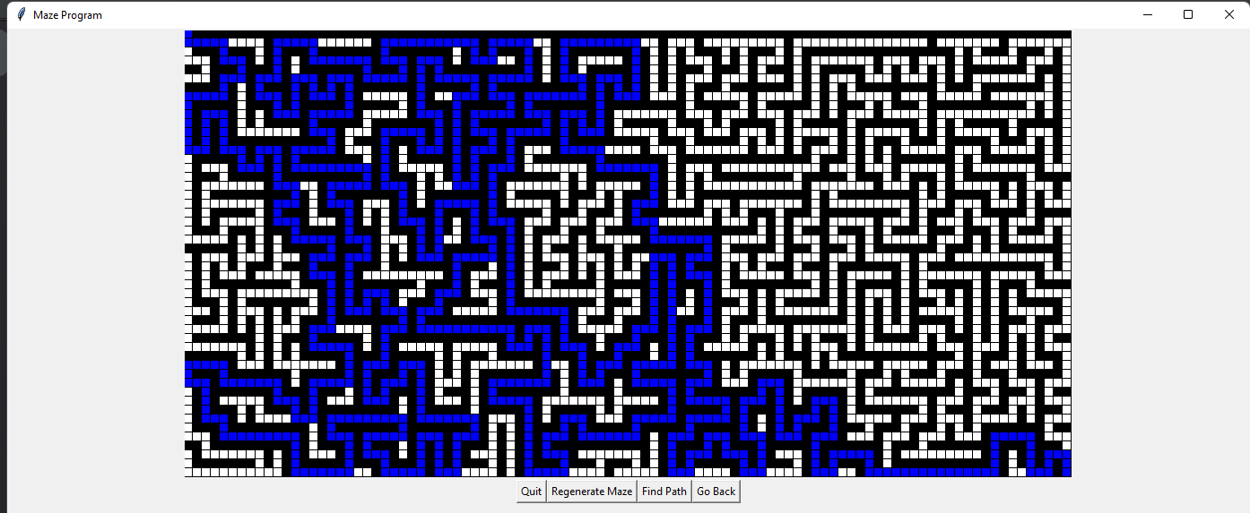

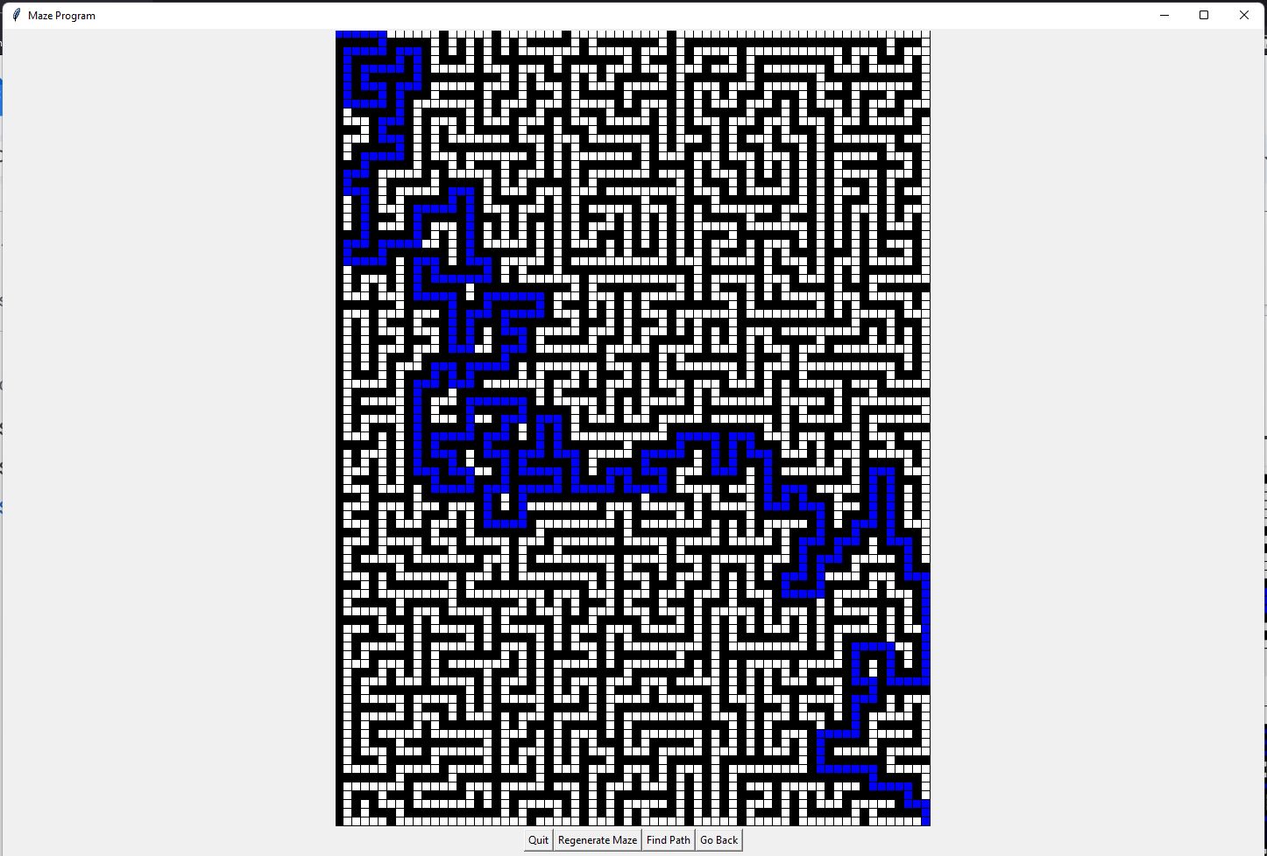

| Date | Test number | Purpose | How test is done | Expected results | Actual results | Next step |
| --- | --- | --- | --- | --- | --- | --- |
| 6 Nov 2023 | 73 | Test if the new randomize button I implemented works as expected | Run program -> make maze -> randomize -> go back -> randomize -> go back -> randomize | All mazes should be correctly generated even when the height and width are randomised | **SUCCESS**As expected. No error occurred and the mazes were correctly generated. | Test if there are cases when the program is unable to generate a maze with the given height and width as coordinates |

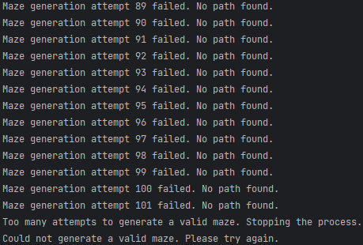

| Date | Test number | Purpose | How test is done | Expected results | Actual results | Next step |
| --- | --- | --- | --- | --- | --- | --- |
| 6 Nov 2023 | 74 | Test if sometimes the maze generation attempt fails continuously | Added print statements in the loop to regenerate the maze until the path is found. | It should go on without stopping, only stopping when it hits the limit. For example “Too many attempts to generate a valid maze. Stopping the process” | **SUCCESS**As expected. The program attempted to generate a maze 100 times but failed. | Implement a warning dialog that will pop up when the program rarely fails to generate the maze |

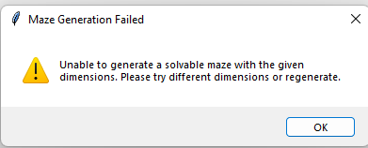

| Date | Test number | Purpose | How test is done | Expected results | Actual results | Next step |
| --- | --- | --- | --- | --- | --- | --- |
| 6 Nov 2023 | 75 | Test if my new warning dialog box correctly works | I set the maximum limit of the amount of times the program can re-try generating the maze to 0, so it will always output a warning error | As soon as I click “Generate” the program will open a warning box telling me that the maze generation failed and that I need to try again with different parameters for height and width or regenerate | **SUCCESS**As expected, on the first try I clicked “Generate maze” it opened up a warning box telling me to try different dimensions or regenerate | Again, test if my new warning dialog box works correctly to make sure it really works |

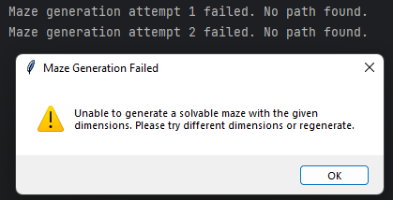

| Date | Test number | Purpose | How test is done | Expected results | Actual results | Next step |
| --- | --- | --- | --- | --- | --- | --- |
| 6 Nov 2023 | 76 | Test if my warning dialog box correctly works | Attempt generating mazes but this time raise the limit to 2 | After a couple of minutes of trying to generate mazes, it should open a warning box at some point. | **SUCCESS**As expected. After some point the program outputs a dialog box since the maze only regenerates 2 times. I raised this to 100 to basically nullify the chance of this happening | Implement ability to save mazes |

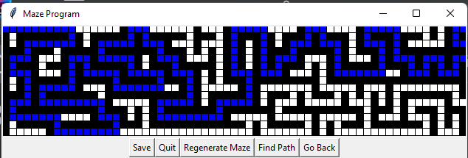

| Date | Test number | Purpose | How test is done | Expected results | Actual results | Next step |
| --- | --- | --- | --- | --- | --- | --- |
| 6 Nov 2023 | 77 | Test if the new “save” button appears | Run program -> make maze -> generate maze | There should be a new “Save” button below the maze, next to the other buttons | **SUCCESS**As expected, a new button appears “Save” | Testing if the “save” button correctly works |

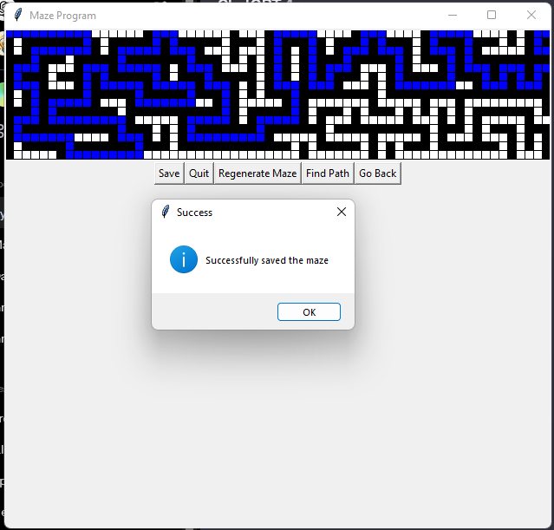

| Date | Test number | Purpose | How test is done | Expected results | Actual results | Next step |
| --- | --- | --- | --- | --- | --- | --- |
| 6 Nov 2023 | 78 | Testing if the “save” button correctly works and saves the maze | Clicking on “Save” button with a maze loaded | It should output an information box telling the user that the maze was successfully saved | **SUCCESS**As expected, the program didn’t crash and successfully output dialog box. | Check if the maze was actually saved |

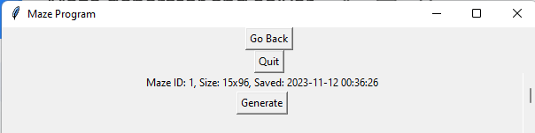

| Date | Test number | Purpose | How test is done | Expected results | Actual results | Next step |
| --- | --- | --- | --- | --- | --- | --- |
| 7 Nov 2023 | 79 | Check if the maze was actually saved | Go to the main menu, then click on “My mazes” | It should show that there is 1 maze that was saved, with the exact parameters and the time stamp that it was saved. “My mazes” should also have button to generate the maze | **SUCCESS**As expected. I can see the same maze, with Maze ID 1. It has the same parameters as I entered and the date is correct | Test if the “Generate” button works to make the same identical maze |

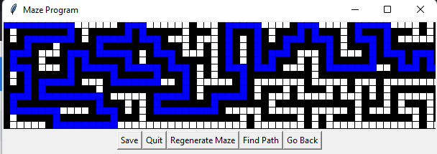

| Date | Test number | Purpose | How test is done | Expected results | Actual results | Next step |
| --- | --- | --- | --- | --- | --- | --- |
| 7 Nov 2023 | 80 | Test if the “Generate” button works | In the “my mazes” menu, click on “generate” | The same exact maze should be generated and have the same path | **SUCCESS**As expected, the identical maze was generated and when I clicked on “Find path” it showed the same path | Test if the normal generation functionality still works and I haven’t broken the program |

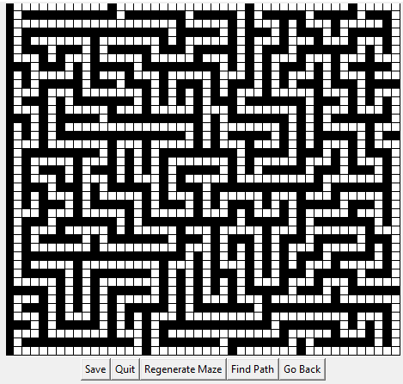

| Date | Test number | Purpose | How test is done | Expected results | Actual results | Next step |
| --- | --- | --- | --- | --- | --- | --- |
| 7 Nov 2023 | 81 | Test if the normal generation functionality still works and I haven’t broken the program | Run program -> Make maze -> Randomize | There should be a maze generated with random parameters | **SUCCESS**As expected, a maze was correctly generated | Test if saving the maze and then regenerating it will restore the same identical maze |

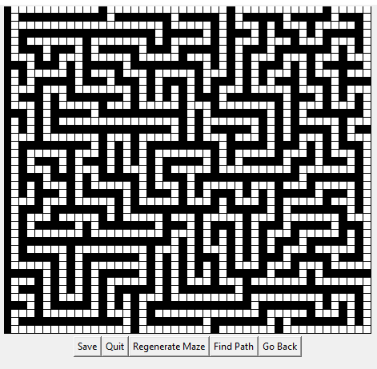

| Date | Test number | Purpose | How test is done | Expected results | Actual results | Next step |
| --- | --- | --- | --- | --- | --- | --- |
| 7 Nov 2023 | 82 | Test if saving the maze and then regenerating it will restore the same identical maze | Click on “Save”, then go to the main menu -> “My mazes” and find the maze that was just recently saved, and then click on “Generate” | The same exact maze should be generated as I saved it | **SUCCESS**As expect, the identical maze that was generated is the same maze that I saved. | Test the maze saving functionality with a non-perfect maze (prim’s algorithm) |

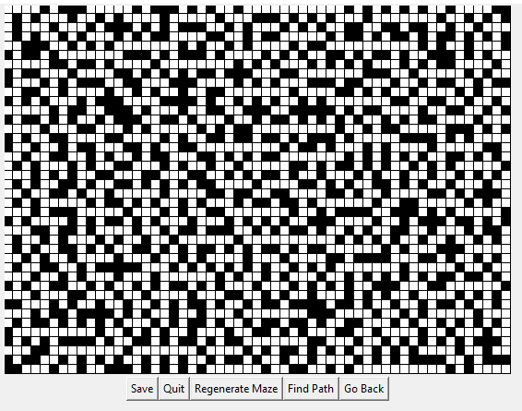

| Date | Test number | Purpose | How test is done | Expected results | Actual results | Next step |
| --- | --- | --- | --- | --- | --- | --- |
| 7 Nov 2023 | 83 | Test the maze saving functionality with a non-perfect maze (prim’s algorithm) | Main menu -> Make maze -> Non-perfect -> Randomize | It should create a randomized maze using Prim’s algorithm | **SUCCESS**As expected, a non-perfect maze is created using Prim’s algorithm | Save the current maze and attempt to “Generate” it again in “My mazes” |

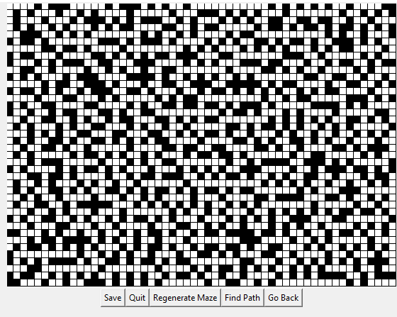

| Date | Test number | Purpose | How test is done | Expected results | Actual results | Next step |
| --- | --- | --- | --- | --- | --- | --- |
| 8 Nov 2023 | 84 | To test if the maze saving functionality works with non-perfect mazes | Saving the maze, then going Main menu -> My mazes -> Generate maze | It should re-generate the same exact maze as I had just saved | **SUCCESS**Exactly as expected. It successfully generated the stored maze despite it using a different algorithm | Test if the scrollbar in “my mazes” menu works when there are a lot of mazes |

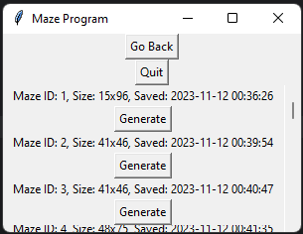

| Date | Test number | Purpose | How test is done | Expected results | Actual results | Next step |
| --- | --- | --- | --- | --- | --- | --- |
| 8 Nov 2023 | 95 | Test if the scrollbar is visible in the “my mazes” menu | I created a lot of mazes so they are not visible on the screen, so it would require scrolling to see them all | The scrollbar should be visible | **SUCCESS**The scrollbar is there, I can see it | Test the scrollbar functionality |

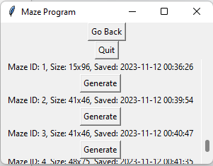

| Date | Test number | Purpose | How test is done | Expected results | Actual results | Next step |
| --- | --- | --- | --- | --- | --- | --- |
| 8 Nov 2023 | 86 | Test the scrollbar functionality, will the scrollbar correctly scroll down and drag the menu down | Holding the scrollbar down and moving the mouse down | The scrollbar should move down, along with the saved mazes, I should see less mazes at the top and more at the bottom | **FAIL**.The scrollbar successfully moves, however the functionality to have the saved mazes also move down doesn’t work. | Fix the scrollbar and have it correctly work by scrolling down the list of mazes so we can see more mazes |

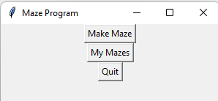

| Date | Test number | Purpose | How test is done | Expected results | Actual results | Next step |
| --- | --- | --- | --- | --- | --- | --- |
| 8 Nov 2023 | 87 | Test if the program still runs correctly after I have made some changes to my code | Running the program | The program should run without fault and correctly display the main menu | **SUCCESS**.The program runs as expected with no issues | Test the scrollbar functionality and see if it actually correctly scrolls the list of mazes down |

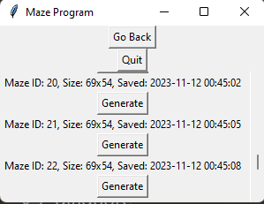

| Date | Test number | Purpose | How test is done | Expected results | Actual results | Next step |
| --- | --- | --- | --- | --- | --- | --- |
| 9 Nov 2023 | 88 | Test if the scrollbar works correctly by ensuring that when it goes down, so should the list of mazes | Going main menu -> my mazes -> move scrollbar down | My mazes should scroll down revealing more saved mazes, and so should the scrollbar visual update | **SUCCESS**.As expected. As I move the scrollbar down so does the list of all saved mazes move down. | Implement ways to delete mazes from the my mazes menu |

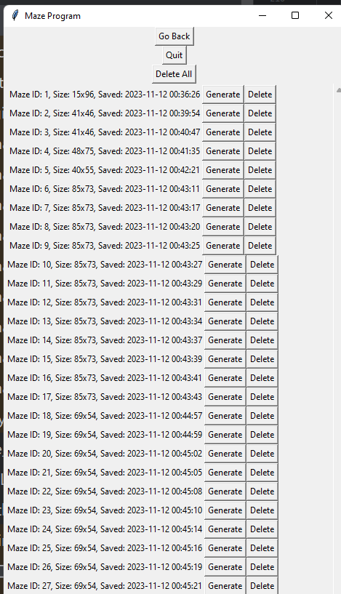

| Date | Test number | Purpose | How test is done | Expected results | Actual results | Next step |
| --- | --- | --- | --- | --- | --- | --- |
| 9 Nov 2023 | 89 | Test if the maze delete maze buttons appear, “Delete” for each individual maze and “Delete All” | Running program -> My mazes | Alongside each saved maze, a “Delete” button should appear. Additionally, a “Delete All” button should appear at the top | **SUCCESS**.As expected, alongside each saved maze, a “Delete” button appears. Additionally, a “Delete All” button appears at the top | Test if the individual delete buttons work and delete individual mazes from the database |



| Date | Test number | Purpose | How test is done | Expected results | Actual results | Next step |
| --- | --- | --- | --- | --- | --- | --- |
| 10 Nov 2023 | 90 | Test if the individual delete buttons work and delete individual mazes from the database | Running the program -> My mazes -> Delete | A maze should be successfully deleted from the database | **SUCCESS**.When I click the Delete button, the maze is deleted from the database successfully | Test if newly saved mazes IDs are correctly appointed, if Maze 6 has been deleted, and the highest maze stored is Maze 28, then a newly saved maze should have ID of 29 and not 6. |





| Date | Test number | Purpose | How test is done | Expected results | Actual results | Next step |
| --- | --- | --- | --- | --- | --- | --- |
| 10 Nov 2023 | 91 | Test if newly saved mazes IDs are correctly appointed, if Maze 6 has been deleted, and the highest maze stored is Maze 28, then a newly saved maze should have ID of 29 and not 6. | Running the program -> Make maze -> Generate maze -> save maze -> go back -> go back -> my mazes | A maze with an ID of 29 should be created as just recently the maze with ID 6 has been deleted. | **SUCCESS**.As expected, when I have deleted maze with ID 6 and I save a new maze, it doesn’t attempt to fit the new maze in-between maze 5 and 7, but rather it finds the highest ID maze and the newly saved Maze has an ID incremented by +1 compared to the previously highest ID | Test the confirmation window that should open up when I want to delete all mazes. It should prompt the user with a “Yes” and “No”, if the user chooses “Yes” then it will proceed to delete all the mazes. If the user chooses “No” then it will not delete everything. |

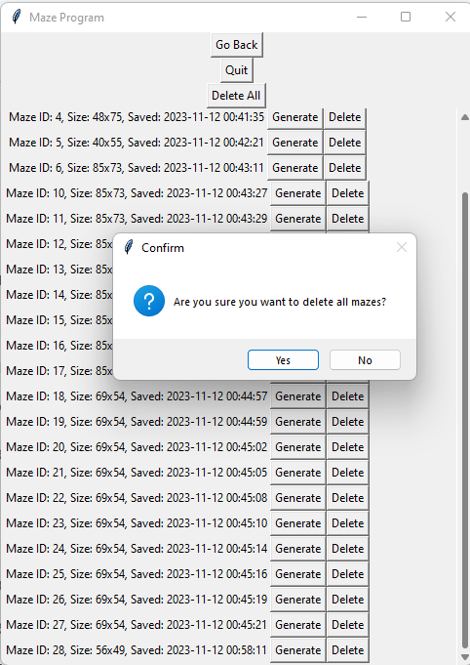

| Date | Test number | Purpose | How test is done | Expected results | Actual results | Next step |
| --- | --- | --- | --- | --- | --- | --- |
| 10 Nov 2023 | 92 | Test the confirmation window that should open up when I want to delete all mazes. It should prompt the user with a “Yes” and “No”, if the user chooses “Yes” then it will proceed to delete all the mazes. If the user chooses “No” then it will not delete everything. | Running the program -> My mazes -> Delete all button | It should prompt the user with a “Yes” and “No”, if the user chooses “Yes” then it will proceed to delete all the mazes. If the user chooses “No” then it will not delete everything | **SUCCESS**.As expected, it prompted the user with a “Yes” and “No”, if I chose “Yes” then it proceed to delete all the mazes. If I chose “No” then it doesn’t delete everything | Test if the maze deleting functionality actually works and it deletes all the mazes from the database when I press on “Delete all” and confirm it |

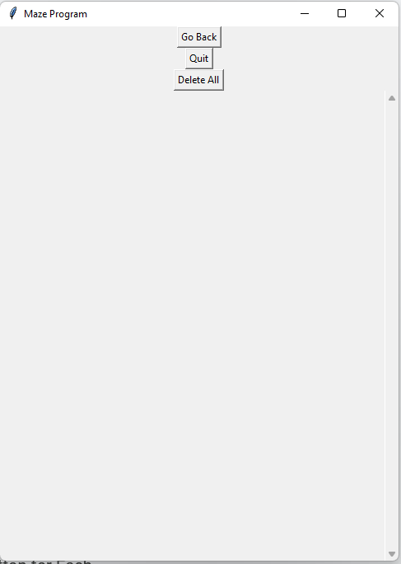

| Date | Test number | Purpose | How test is done | Expected results | Actual results | Next step |
| --- | --- | --- | --- | --- | --- | --- |
| 10 Nov 2023 | 93 | Test if the maze deleting functionality actually works and it deletes all the mazes from the database when I press on “Delete all” and confirm it | Running the program -> My mazes -> Delete all -> Yes (confirmation dialog) | It should delete all mazes from the database and there should be no mazes displayed | **SUCCESS**.It successfully deleted every maze and no maze was displayed anymore | Test what happens when you attempt to delete all mazes when there are no mazes to delete. |

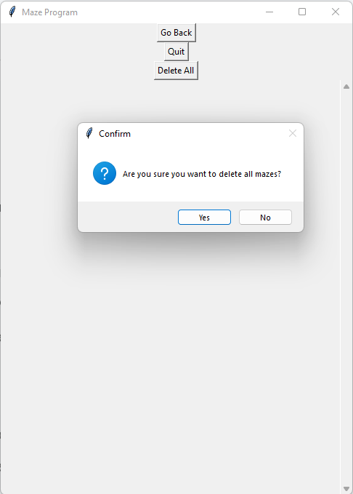

| Date | Test number | Purpose | How test is done | Expected results | Actual results | Next step |
| --- | --- | --- | --- | --- | --- | --- |
| 11 Nov 2023 | 94 | Test what happens when you attempt to delete all mazes when there are no mazes to delete. | Run the program -> My mazes -> Delete All | Since there are no mazes in the database, it should not crash and the program should inform the user that there are no mazes to be deleted. | **FAIL**. Instead of informing the user that there are no mazes to be deleted it instead asks the user for confirmation if they want to delete the maze. | Implement some changes to my code and test if the new functionality that deletes all mazes tells the user that there are no mazes to delete. |

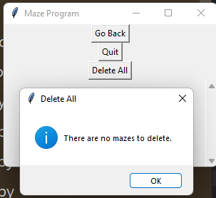

| Date | Test number | Purpose | How test is done | Expected results | Actual results | Next step |
| --- | --- | --- | --- | --- | --- | --- |
| 11 Nov 2023 | 95 | Implement some changes to my code and test if the new functionality that deletes all mazes tells the user that there are no mazes to delete. | Running the program -> My mazes -> Ensure there are no mazes saved -> Delete all mazes | Since there are no mazes saved, instead of attempting to delete the mazes, it should warn the user that there are no mazes to delete by opening a dialog box | **SUCCESS**.As expected, a dialog box opens telling the user that there are no mazes to delete | Implement a user authentication system and test if when the program is run the required components are displayed: Sign Up button, Log In button, and “Show Password” button. Additionally, there should be two fields: Field to enter the password and another field to enter the username. |

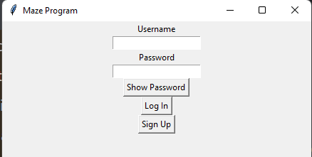

| Date | Test number | Purpose | How test is done | Expected results | Actual results | Next step |
| --- | --- | --- | --- | --- | --- | --- |
| 11 Nov 2023 | 96 | Test if when the program is run the required components are displayed: Sign Up button, Log In button, and “Show Password” button. Additionally, there should be two fields: Field to enter the password and another field to enter the username. | Running the program | There should be 2 fields labelled “Username” and “password”. Additionally, there should be 3 buttons, “Show Password”, “Log IN” and “Sign Up” | **SUCCESS**.As expected, there are 2 fields labelled “Username” and “password”. Additionally, there are 3 buttons, “Show Password”, “Log IN” and “Sign Up” | Text if text can be entered into the “Username” field and if the “Password” field can also have text be entered into it. Text entered into the password field should be obscured with ******* and not visible. |

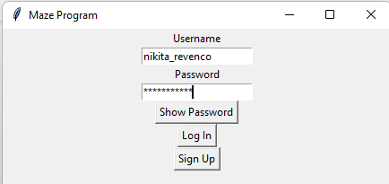

| Date | Test number | Purpose | How test is done | Expected results | Actual results | Next step |
| --- | --- | --- | --- | --- | --- | --- |
| 11 Nov 2023 | 97 | Text if text can be entered into the “Username” field and if the “Password” field can also have text be entered into it. Text entered into the password field should be obscured with ******* and not visible. | Running the program -> Entering text into username and password fields | The username field should show that text has been entered into it. The password field should show stars in place of every character. | **SUCCESS**.As expected, the username field shows that text has been entered into it. The password field shows stars in place of every character. | Test if the show password button works correctly. it should show the password without having it be obscured by stars (******) and the button’s text should have changed to “Hide Password” |

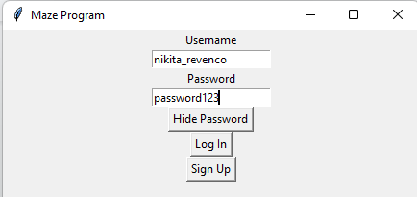

| Date | Test number | Purpose | How test is done | Expected results | Actual results | Next step |
| --- | --- | --- | --- | --- | --- | --- |
| 11 Nov 2023 | 98 | Test if the show password button works correctly. it should show the password without having it be obscured by stars (******) and the button’s text should have changed to “Hide Password” | Running the program -> Entering characters in the password field -> Pressing on “show password” button | The text should not be obscured by stars anymore in the password field, and the button’s text should have changed to “hide password” | **SUCCESS**.As expected, the text is not obscured by stars anymore in the password field, and the button’s text has changed to “hide password” | Test if a warning window pops up when the user enters invalid username or password |

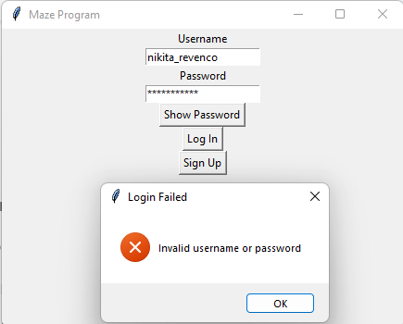

| Date | Test number | Purpose | How test is done | Expected results | Actual results | Next step |
| --- | --- | --- | --- | --- | --- | --- |
| 11 Nov 2023 | 99 | Test if a warning window pops up when the user enters invalid username or password | running the program -> entering a username or password that is not valid (not stored in the database) | An error window should pop up informing the user that the username or password they have entered is incorrect | **SUCCESS**.As expected, an error window popped up informing the user that the username or password they have entered is incorrect | Test if a new window opens when I click on the “sign up” button |

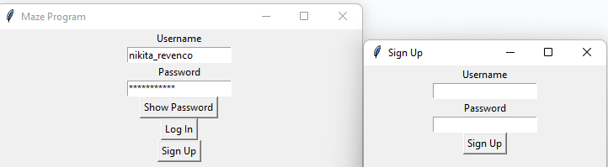

| Date | Test number | Purpose | How test is done | Expected results | Actual results | Next step |
| --- | --- | --- | --- | --- | --- | --- |
| 11 Nov 2023 | 100 | Test if a new window opens when I click on the “sign up” button | Running the program -> Clicking on “Sign Up” button | A new window should open up that has the title of “Sign Up”, it has one button “Sign Up” and two entry fields , username entry field and a password entry field. | **SUCCESS**.As expected , a new window opened up that has the title of “Sign Up”, it also has one button “Sign Up” and two entry fields , username entry field and a password entry field. | Test if the username and password entry fields work and allow text to be entered into them |

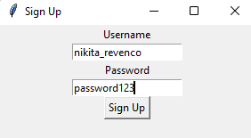

| Date | Test number | Purpose | How test is done | Expected results | Actual results | Next step |
| --- | --- | --- | --- | --- | --- | --- |
| 11 Nov 2023 | 101 | Test if the username and password entry fields work and allow text to be entered into them | Running the program -> Sign up -> Enter text into the password and username entry fields | Text should be able to be input into the two entry fields and the password field should not be obstructed as that functionality has not been implemented yet | **SUCCESS**.As expected, text is be able to be input into the two entry fields and the password field is not obstructed as that functionality has not been implemented yet | Test if the sign up functionality works |

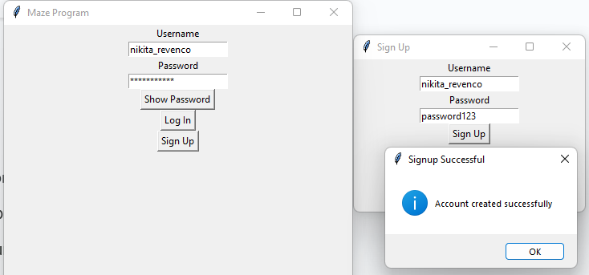

| Date | Test number | Purpose | How test is done | Expected results | Actual results | Next step |
| --- | --- | --- | --- | --- | --- | --- |
| 11 Nov 2023 | 102 | Test if the sign up functionality works | Running the program -> sign up -> Enter values for username and password that are not currently stored in the database -> Click sign up button again | The username should be added to the database, and the password used should be hashed and salted and then that is added to the database. An information window telling the user that the signup was successful should pop up. | **SUCCESS**.As expected,the username is added to the database, and the password used is hashed and salted and then that is added to the database. An information window telling the user that the signup was successful popped up. | Test if signing up with the same username as already stored in the database outputs an error dialog warning the user that the username is already stored and a duplicate cannot be created |

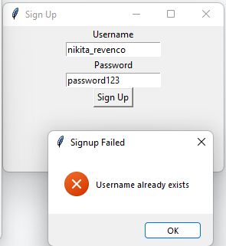

| Date | Test number | Purpose | How test is done | Expected results | Actual results | Next step |
| --- | --- | --- | --- | --- | --- | --- |
| 11 Nov 2023 | 103 | Test if signing up with the same username as already stored in the database outputs an error dialog warning the user that the username is already stored and a duplicate cannot be created | Running the program -> Clicking on sign up button -> Entering a username that already exists in the database into the username field and entering any password -> Clicking “Sign up” | It should output an error box with the title “Signup Failed” saying that “Username already exists”, and an “OK” option that exists the window. | **SUCCESS**.As expected an error box is output telling the user that the signup failed and that the username already exists. | Test if the login functionality works by logging in with a valid username and password |



| Date | Test number | Purpose | How test is done | Expected results | Actual results | Next step |
| --- | --- | --- | --- | --- | --- | --- |
| 11 Nov 2023 | 104 | Test if the login functionality works by logging in with a valid username and password | running the program -> Inputting valid username and password -> Clicking on “Log In” button | The program should successfully log the user into the program when they click on “Sign in” | **SUCCESS**.As expected, the user is granted access to the program | Test if the program runs and doesn’t crash |

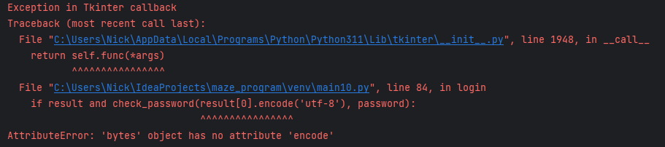

| Date | Test number | Purpose | How test is done | Expected results | Actual results | Next step |
| --- | --- | --- | --- | --- | --- | --- |
| 11 Nov 2023 | 105 | Test if the program runs and doesn’t crash | Running the program | The program should run with no error | **FAIL**. An AttributeError is output telling me that ‘bytes’ object has no attribute ‘encode’ when I try to run the program | Fix the AttributeError and have the program correctly start |

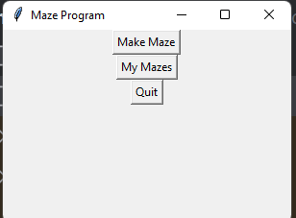

| Date | Test number | Purpose | How test is done | Expected results | Actual results | Next step |
| --- | --- | --- | --- | --- | --- | --- |
| 12 Nov 2023 | 106 | Test if the issue has been resolved and the program now runs successfully | Running the program | The program should run successfully with no error | **SUCCESS**. The program correctly runs and doesn’t crash when I try to run it, it also doesn’t give me an error | Test if I can login as admin and open the admin console by logging in with “admin123” as both the username and the password |

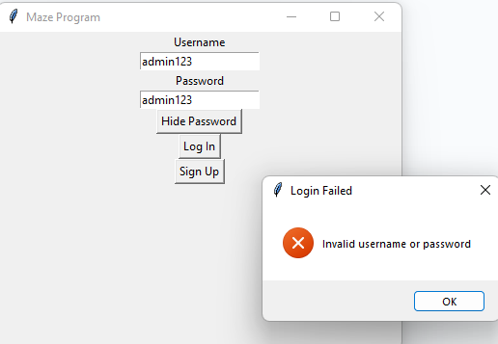

| Date | Test number | Purpose | How test is done | Expected results | Actual results | Next step |
| --- | --- | --- | --- | --- | --- | --- |
| 12 Nov 2023 | 107 | Test if the new admin login functionality works correctly | Running the program → Logging in with username and password both being “admin123” | When I enter admin123 for both the password and the username, instead of sending me to the main menu, it should send me to a special admin console where I can overview all the users currently registered in the program | **FAIL**. The program is telling me that the username or password was invalid, not letting me open the admin console | Add a special case for admin123 in the code, so it allows me to access the program despite admin123 not being actually stored in the database |

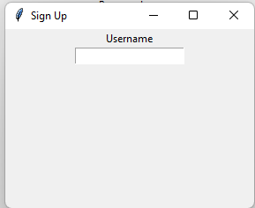

| Date | Test number | Purpose | How test is done | Expected results | Actual results | Next step |
| --- | --- | --- | --- | --- | --- | --- |
| 12 Nov 2023 | 108 | Test if the sign up functionality still works | Running the program → Sign up | When I click on Sign Up it should open a menu with a password and a username entry field, additionally a button to sign up | **FAIL**. Only the username entry field is visible, and the button to sign up is not visible as well as the password entry field. | Attempt to fix this by having the sign up window have all the required elements, which is both the Username and Password entry fields aswell as the 2 buttons, “show password”, and “sign up” |

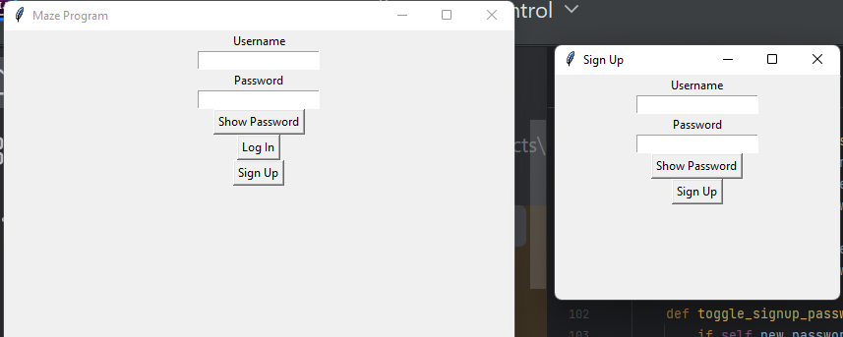

| Date | Test number | Purpose | How test is done | Expected results | Actual results | Next step |
| --- | --- | --- | --- | --- | --- | --- |
| 12 Nov 2023 | 109 | Test if the program has been fixed now and the program successfully opens with no crashes. Additionally, when I open the sign up window it should successfully display the username and password entry fields as well as the show password and sign up button | Running the program → Sign up | The signup window should contain two entry fields with labels “username” and “password”, additionally it should have two buttons “sign up” and “show password” | **SUCCESS**. The program correctly displays all the required elements to me and I can see the two buttons, “show password” and “sign up” as well as the two entry fields, “username” and “password” | Test if the password obscuring functionality still works as intended and when I type the password in the password field it shows it as stars ** |

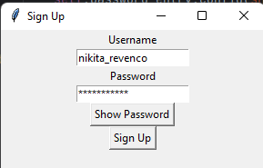

| Date | Test number | Purpose | How test is done | Expected results | Actual results | Next step |
| --- | --- | --- | --- | --- | --- | --- |
| 12 Nov 2023 | 110 | Test if when I enter password in the entry field in the sign up window, if it successfully obscures the password with stars (****) | Running the program → Sign up → Entering text into the “username” and “password” entry fields | The program should correctly take input from the user and allow me to enter text into both the username and password, and when I enter text into the password entry field it should display it as stars and obscure it. | **SUCCESS**. The program allows me to enter text into the username and password entry fields. When I enter text into the password entry field it instead displays it as stars instead of raw text. | Test if the “show password” functionality works correctly and allows me to convert the password from being displayed as stars to being displayed as normal text, and then when I click it again it should convert back. |

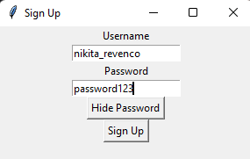

| Date | Test number | Purpose | How test is done | Expected results | Actual results | Next step |
| --- | --- | --- | --- | --- | --- | --- |
| 12 Nov 2023 | 111 | Test if the “show password” functionality works correctly in the sign up window. | Running the program → Sign up → enter text into the password entry field → Show password → hide password | When I click on “Show password” button the password should no longer be obscured by stars (******) and now the password should be renamed to “Hide Password”, after this when I click on “hide password” again it should convert back to original and display the password as stars | **SUCCESS**. The “hide/show password” button correctly toggles between showing the password as stars and showing the password in raw text form. | Test if the signup button works correctly and allows me to sign up and have a new username and password be entered into the database |

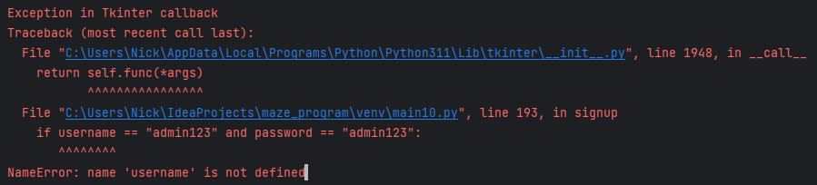

| Date | Test number | Purpose | How test is done | Expected results | Actual results | Next step |
| --- | --- | --- | --- | --- | --- | --- |
| 12 Nov 2023 | 112 | Test if the signup functionality still works correctly and leads to no errors or crashes | Running the program → Sign up → Entering valid credentials | The program should run correctly with no errors and allow me to create a new account | **FAIL**. The program crashed and gave me a NameError | Fix the NameError and hopefully the program will start working again |

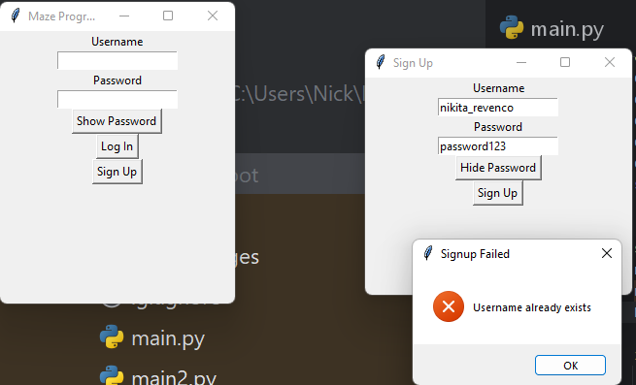

| Date | Test number | Purpose | How test is done | Expected results | Actual results | Next step |
| --- | --- | --- | --- | --- | --- | --- |
| 12 Nov 2023 | 113 | Test if I have fixed the issue with the signup not working | Running the program → Signing up with user credentials that already exist | It should run the program with no crashes and open an error box telling me that I cannot sign up with that username because it already exists | **SUCCESS**. As expected, the error dialog opens telling me that the username already exists instead of crashing the program which is the desired outcome | Test with another username that doesn’t exist in the database to see if the sign up functionality has really been fixed |

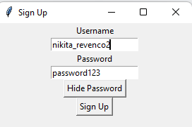

| Date | Test number | Purpose | How test is done | Expected results | Actual results | Next step |
| --- | --- | --- | --- | --- | --- | --- |
| 12 Nov 2023 | 114 | Test again to make sure I have really fixed the issue | Running the program → Sign up → Signing up with a username and password that don’t exist in the database | The program should allow me to sign up since the new username doesn’t exist in the database | **SUCCESS**. The program let me sign up with a new username that hasn’t already been used in the database | Test if the signup window closes when I click “OK” in the “Sign up Successful” information dialog |

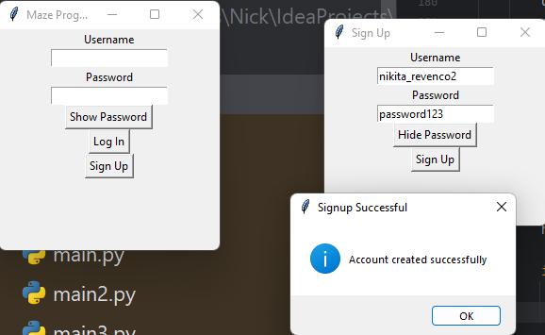

| Date | Test number | Purpose | How test is done | Expected results | Actual results | Next step |
| --- | --- | --- | --- | --- | --- | --- |
| 12 Nov 2023 | 115 | Test if the sign up window terminates when I click on Sign up and then “OK” in the “signup successful” popup | Running the program → Signing up with valid credentials → Clicking “OK” when the information dialog opens up | Both the information dialog and the sign up window should close when I click on “OK” | **SUCCESS**. As expected, both close when I click on “OK” in the information dialog | Test if the admin panel works correctly and I can sign in with the admin credentials |

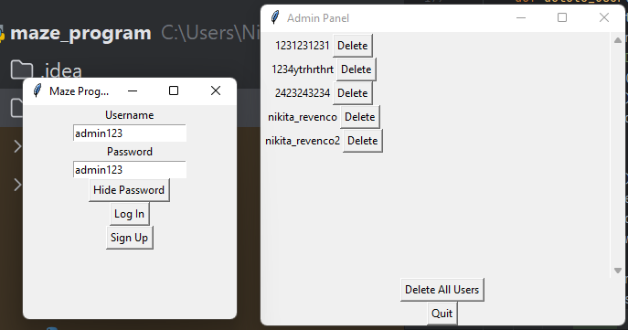

| Date | Test number | Purpose | How test is done | Expected results | Actual results | Next step |
| --- | --- | --- | --- | --- | --- | --- |
| 12 Nov 2023 | 116 | Test if the admin login functionality works correctly and I can sign in with “admin123” as both username and password | Running the program → Signing in as “admin123” for both username and password | It should display the admin panel and all the current users. Additionally, there should be an option to ‘delete’ individual users, and an option to quit the program, and another option to delete all users. | **SUCCESS**. The admin panel opens when I log in with the admin login credentials, and it allows me to oversee all users that are stored in the database (except admin123) and delete individual users, as well as there are 2 buttons: Delete All Users and “Quit” | Test if the “delete” button works correctly in the admin panel and allows me to delete individual users from the database |

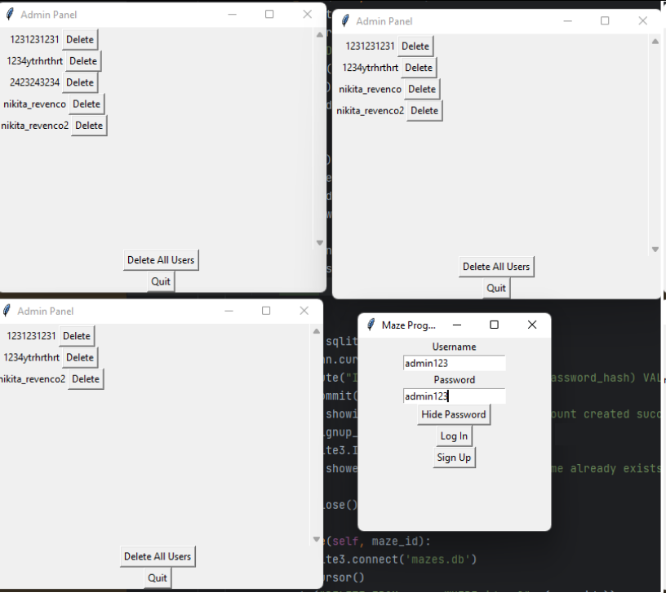

| Date | Test number | Purpose | How test is done | Expected results | Actual results | Next step |
| --- | --- | --- | --- | --- | --- | --- |
| 12 Nov 2023 | 117 | Test, by deleting 3 usernames if the delete button works correctly and deletes the users from the database | Running the program → Logging in with “admin123” for both username and password → Delete → Delete → Delete | The program should allow me to delete individual users from the database. When I delete a user it shouldn’t be displayed anymore | **FAIL**. Deleting individual users works, but instead of refreshing the current window it creates a completely new window. If there are 5 users and I delete 1, it will open a new window with 4 users in it, so on. | Fix new windows being opened each time I delete a user and have the admin panel refresh everytime I Delete a user |

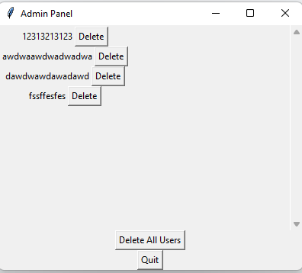

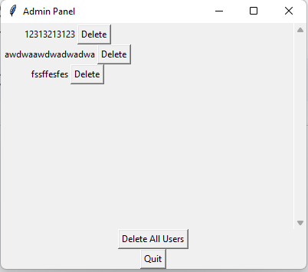

| Date | Test number | Purpose | How test is done | Expected results | Actual results | Next step |
| --- | --- | --- | --- | --- | --- | --- |
| 13 Nov 2023 | 118 | Test again if the delete buttons work correctly and delete individual users from the database. | Running the program → Logging in with “admin123” as both username and password → Delete → Delete | It should no longer open a new window everytime I delete a user, instead it should refresh the current window | **SUCCESS**. The program doesn’t open a new window everytime anymore, and refreshes the current window instead. | Add a confirmation window that should open when the admin wants to delete all users. It should ask the user if they are sure and have two options: Yes and No |

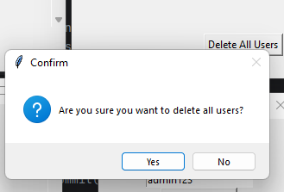

| Date | Test number | Purpose | How test is done | Expected results | Actual results | Next step |
| --- | --- | --- | --- | --- | --- | --- |
| 12 Nov 2023 | 119 | Test if there is a confirmation window opening up asking the admin if they are really certain they want to delete all the users when they click “Delete All” and test if the confirmation dialog can be exited by pressing “no” | Running the program → Logging in as admin using “admin123” for both the username and the password → Delete All → no | The program should ask the admin if they are sure they want to delete all the users from the database. When clicking “no” it should close the confirmation dialog. | **SUCCESS**. The confirmation dialog opens up when I try to delete all users from the database. Additionally, when I click “no” it closes the confirmation dialog | Test if the “delete all users” button actually works and deletes all users from the database when its clicked |

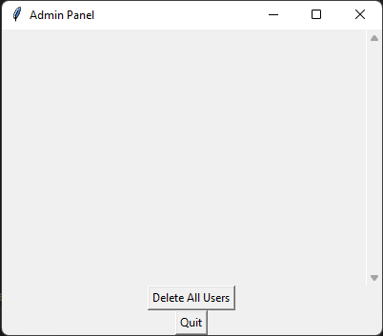

| Date | Test number | Purpose | How test is done | Expected results | Actual results | Next step |
| --- | --- | --- | --- | --- | --- | --- |
| 12 Nov 2023 | 120 | Test if the “Delete All Users” functionality works correctly and deletes all users from the database. It should delete all users except admin123 | Running the program → Logging in with “admin123” as username and password → “Delete all users” → “Yes” | All the users should be deleted from the database and no longer be displayed | **SUCCESS**. All users are deleted except admin123 and no users can be seen in the admin panel | Test if a confirmation dialog opens when trying to delete all users from the database despite there being no users (except admin123) |

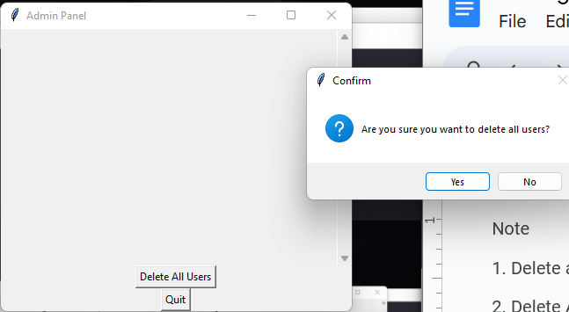

| Date | Test number | Purpose | How test is done | Expected results | Actual results | Next step |
| --- | --- | --- | --- | --- | --- | --- |
| 12 Nov 2023 | 121 | Test if there is an information dialog opening up notifying the user that there are no users to delete if they try to “Delete All” while there are no users in the database | Running the program → Logging in with “admin123” as username and password → Delete all users → yes | An information dialog should open telling us that there are no users in the database. The only option for the information dialog should be “OK”. When clicking that option, the information dialog should close. | **FAIL**. When there are no users in the database, an information dialog doesn’t open telling the admin that. Instead, a confirmation dialog opens asking the admin if they really want to delete all users from the database. | Test if the admin window opens in a new window or the current window when I login with “admin123” for both username and password |

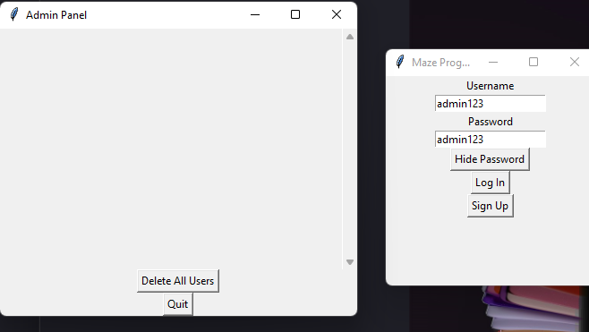

| Date | Test number | Purpose | How test is done | Expected results | Actual results | Next step |
| --- | --- | --- | --- | --- | --- | --- |
| 13 Nov 2023 | 122 | Test if the admin window opens in a new window or the current window when I login with “admin123” for both username and password | Running the program → logging in with “admin123” as both the username and the password | The admin panel should open in a new window , and not destroy any widgets in the main “maze program” window | **SUCCESS**. The program opens the admin panel in a completely new window. It doesn’t replace the login screen. | Test if it still prints the information dialog that there are no users to delete when I try to “delete all” when there are no users in the database |

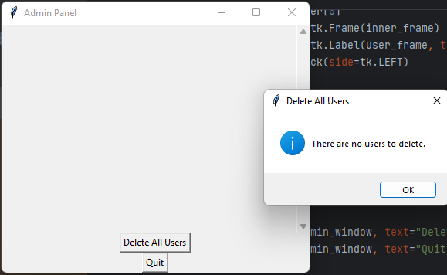

| Date | Test number | Purpose | How test is done | Expected results | Actual results | Next step |
| --- | --- | --- | --- | --- | --- | --- |
| 13 Nov 2023 | 123 | Test again if it still prints the information dialog that there are no users to delete when the admin tries to delete all users when there are none in the database. | Running the program → Logging in as “admin123” for both the username and the password → Delete all → yes → Delete all → OK | When there are no users in the database, it should open an information dialog telling the admin that there are no users to delete | **SUCCESS**. When there are no users stored in the database, it doesn’t attempt to delete users when there are none. Instead it opens an information dialog telling the user that there are no users to delete. | Test if the scrollbar background appears in the admin panel when all elements fit onto one screen. No actual scrollbar should appear. |

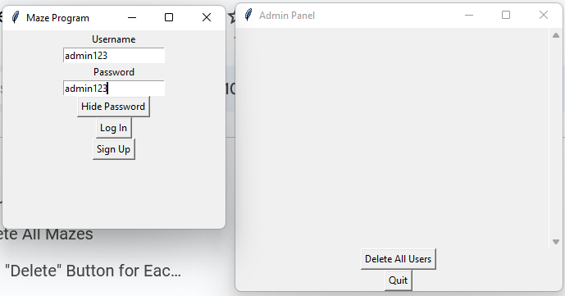

| Date | Test number | Purpose | How test is done | Expected results | Actual results | Next step |
| --- | --- | --- | --- | --- | --- | --- |
| 13 Nov 2023 | 124 | Test if the scrollbar background appears in the admin panel when all elements fit onto one screen. No actual scrollbar should appear. | Running the program → Logging in as “admin123” for both the username and the password | There should be a scrollbar background, but no scrollbar should appear. | **SUCCESS**. The scrollbar background appears but it doesn’t do anything since all elements can fit onto the screen | Add a scrollbar that will appear when there are too many users and not all of them can be shown on the screen at once. The scrollbar should allow scrolling up and down |

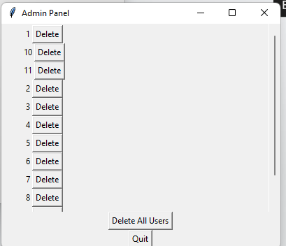

| Date | Test number | Purpose | How test is done | Expected results | Actual results | Next step |
| --- | --- | --- | --- | --- | --- | --- |
| 14 Nov 2023 | 125 | Test if the scrollbar functionality works correctly when there are a lot of users and can scroll up and down | Running the program → Creating many user accounts → Logging in as “admin123” for both username and password → Scrolling with the scrollbar | The scrollbar should appear on the right hand side. It’ll allow the admin to scroll up and down to see the full list of signed up users at once. | **FAIL**. The scrollbar does appear but it doesn’t work, it can be scrolled with but it just resets to the original position and nothing on the screen is changed. | Fix the scrollbar to have it remember its position and update the elements on the screen and allow to be scrolled up and down |

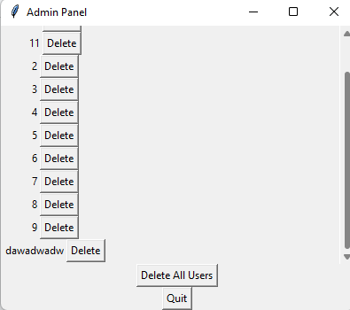

| Date | Test number | Purpose | How test is done | Expected results | Actual results | Next step |
| --- | --- | --- | --- | --- | --- | --- |
| 14 Nov 2023 | 126 | Test if the error has been fixed and now the scrollbar correctly can be used to scroll up and down when there are a lot of usernames in the database and displayed in the admin console | Running the program → Signing in as “admin123” for both the username and the password → Scrolling with the scrollbar | The scrollbar should allow me to scroll up and down and reveal more users on the bottom and hide the users at the top when I scroll down for example | **SUCCESS**. The scrollbar works correctly and lets me scroll up and down and it remembers its position and updates the screen visual dynamically | Test if the login functionality still works correctly and allows me to login into the program with my old saved credentials “nikita_revenco” and “password123” |

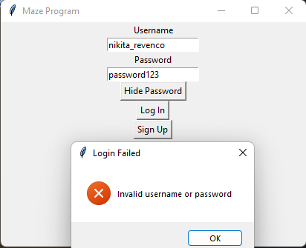

| Date | Test number | Purpose | How test is done | Expected results | Actual results | Next step |
| --- | --- | --- | --- | --- | --- | --- |
| 14 Nov 2023 | 127 | Test if the login functionality works correctly and still allows me to login into the program with my old credentials “nikita_revenco” and “password123” | Running the program → Logging in with a username and a password that is stored in the database | It should grant access to the program and let me log in | **FAIL**. Instead of allowing me to log into the program, it just blocked me from doing so and output an error dialog | Fix the issue and have it let me log in to the program like I used to be able to |

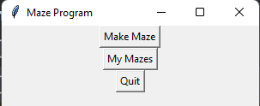

| Date | Test number | Purpose | How test is done | Expected results | Actual results | Next step |
| --- | --- | --- | --- | --- | --- | --- |
| 14 Nov 2023 | 128 | Test if I had correctly resolved the issue and the login functionality works as expected and allows me to login into the program with my previous credentials “nikita_revenco” and “password123” | Running the program → Logging in with a valid username and a password | It should allow me to login correctly and grant me access to the program | **SUCCESS**. It allowed me to login into the program with no issue and no error this time. | Tidy up my code by putting my functions under the MazeApplication class as well as the creation of the databases |

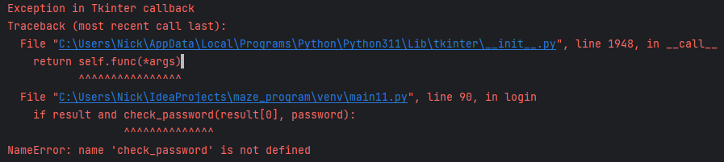

| Date | Test number | Purpose | How test is done | Expected results | Actual results | Next step |
| --- | --- | --- | --- | --- | --- | --- |
| 14 Nov 2023 | 129 | Test if the login functionality hasn’t been broken and I can still login with my credentials “nikita_revenco” and “password123” | Running the program → Logging into the program with a valid username and password | It should grant me access to the program like normal and allow me to login | **FAIL**. It doesn’t let me log in, when I try to hit the “log in” button it outputs a NameError telling me that the check_password function is not defined | Properly define the check_password() function and fix the NameError |

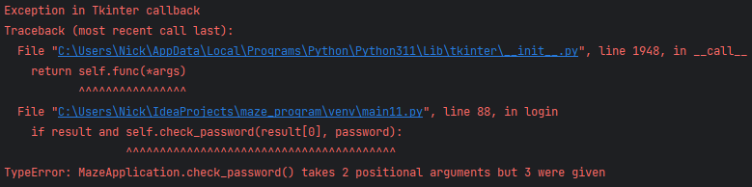

| Date | Test number | Purpose | How test is done | Expected results | Actual results | Next step |
| --- | --- | --- | --- | --- | --- | --- |
| 14 Nov 2023 | 130 | Test if the error has been resolved and I am able to run the program and login with my username | Running the program → entering valid username and password for login → Logging in | The program should grant me access to the main menu and the main maze program | **FAIL**. The program returns a TypeError telling me that I have given too many positional arguments into the check_password() function | Fix the error and give 2 positional arguments instead of 3 to resolve the issue and have the program run |

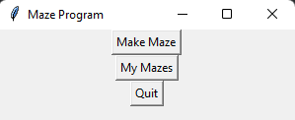

| Date | Test number | Purpose | How test is done | Expected results | Actual results | Next step |
| --- | --- | --- | --- | --- | --- | --- |
| 14 Nov 2023 | 131 | Test if the issue has been resolved and now I am able to run the program and login with my credentials “nikita_revenco” and “password123” | Running the program → Logging in with valid user credentials “nikita_revenco” and “password123” | It should grant me access to the program and allow me to login | **SUCCESS**. It lets me login into the program when I input the correct credentials. No error is given to me this time. | Split the MazeApplication class into two classes, UserAuthentication and MazeApplication to tidy up my code |

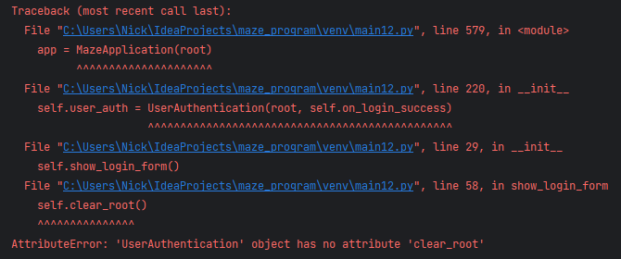

| Date | Test number | Purpose | How test is done | Expected results | Actual results | Next step |
| --- | --- | --- | --- | --- | --- | --- |
| 15 Nov 2023 | 132 | Test if I can run the program and it doesn’t crash after splitting the MazeApplication class into two classes | Running the program | The program should run successfully with no issue. I should be greeted with a login screen at first | **FAIL**. The program gives me an AttributeError telling me the UserAuthentication class has no attribute clear_root | Add the missing attribute to the UserAuthentication class to have the program not crash anymore when trying to run it |

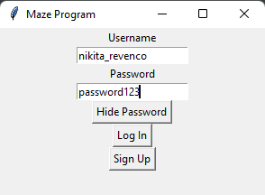

| Date | Test number | Purpose | How test is done | Expected results | Actual results | Next step |
| --- | --- | --- | --- | --- | --- | --- |
| 15 Nov 2023 | 133 | Test if I had fixed the error previously and now the program correctly opens and doesn’t crash anymore | Running the program | It should run with no error this time and let me access the program. I should be able to input the username and password into their respective fields and the hide/show password button should work as expected | **SUCCESS**.When I run the program, it allows me to also input username and password into their respective fields, additionally the hide/show password functionality works as expected | Attempt to login into the program to test that the login method works correctly |

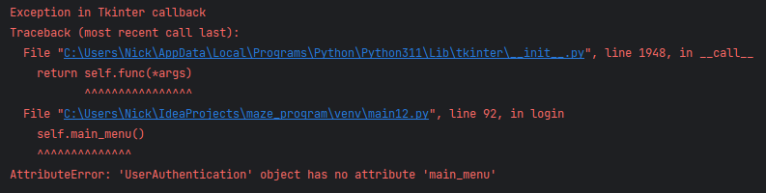

| Date | Test number | Purpose | How test is done | Expected results | Actual results | Next step |
| --- | --- | --- | --- | --- | --- | --- |
| 15 Nov 2023 | 134 | Test if the login functionality works correctly and I am able to login now with my credentials “nikita_revenco” and “password123” | Running the program → Logging in with username “nikita_revenco” and “password123” as the password | The program should grant me access to the main menu with no errors | **FAIL**. The program returns an AttributeError when I try to login despite the login credentials being correct. It is telling me that the UserAuthentication class doesn’t have a main_menu attribute | Add the missing attribute to the UserAuthentication class and hopefully the program will allow me to login after this |

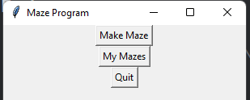

| Date | Test number | Purpose | How test is done | Expected results | Actual results | Next step |
| --- | --- | --- | --- | --- | --- | --- |
| 15 Nov 2023 | 135 | Test if the login functionality works correctly and I am able to login now with my credentials “nikita_revenco” and “password123” | Running the program → Logging in with “nikita_revenco” as the username and “password123” as the password | It should let me access the program and output no errors | **SUCCESS**. It let me into the program when I input the correct credentials | Test if the sign up functionality works and I can sign up with a new username and password |

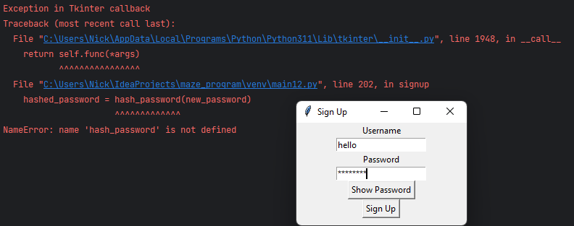

| Date | Test number | Purpose | How test is done | Expected results | Actual results | Next step |
| --- | --- | --- | --- | --- | --- | --- |
| 15 Nov 2023 | 136 | Test if the sign up functionality works and I can sign up with a new username and password | Running the program → Sign up → Signing up with valid credentials → Sign up | The program should create a new entry in the database for my user credentials, and it should correctly hash my password and store that hash in the database | **FAIL**. The program tells me there is a NameError and that hash_password is not defined | Attempt to fix the error and have the program correctly sign me up when I sign up with new credentials |

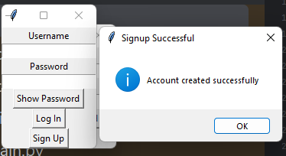

| Date | Test number | Purpose | How test is done | Expected results | Actual results | Next step |
| --- | --- | --- | --- | --- | --- | --- |
| 15 Nov 2023 | 137 | Test if the sign up functionality works and I can sign up with a new username and password | Running the program → Sign up → Entering valid username and password → Sign up | It should open an information dialog telling me that the account creation was successful | **SUCCESS**. It correctly showed me an information dialog letting me know that my account creation was a success | Test if the admin console still works and all the individual components of the admin console still work like deleting individual users, deleting all users, the quit button, and confirmation window opening and having 2 options when I choose delete all users button |

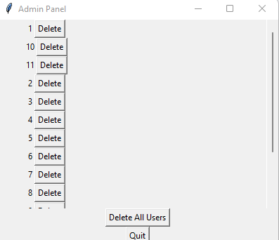

| Date | Test number | Purpose | How test is done | Expected results | Actual results | Next step |
| --- | --- | --- | --- | --- | --- | --- |
| 15 Nov 2023 | 138 | Test if the admin console still works, and all individual components of it still work, such as deleting individual users, deleting all users, then a confirmation window opening up, and if the quit button still works. | Running the program → logging in as “admin123” for both username and password → Click on ”delete” next to individual users → Click on “delete all” → Click on “no” to close confirmation window → Click on “delete all” → Click on “yes” → Click on “quit” | All the functionalities should work as expected, it should open the admin console and let me delete individual users, as well as when I want to delete all users it should open a confirmation dialogue asking the admin if they are sure they want to do that. When the admin says “no” it should close the confirmation dialogue, and when they say “yes” it should delete all users from the database and close the confirmation dialog. finally, when I click on “quit” it should end the program | **SUCCESS**. As expected, all the functionalities work as expected, it opens the admin console and lets me delete individual users, as well as when I want to delete all users it opens a confirmation dialog asking the admin if they are sure they want to do that. When the admin says “no” it closes the confirmation dialog, and when they say “yes” it deletes all users from the database and closes the confirmation dialog. finally, when I click on “quit” it ends the program | Test if the generate maze functionality still works and allows me to generate a maze after I’ve completely re-structured my code |

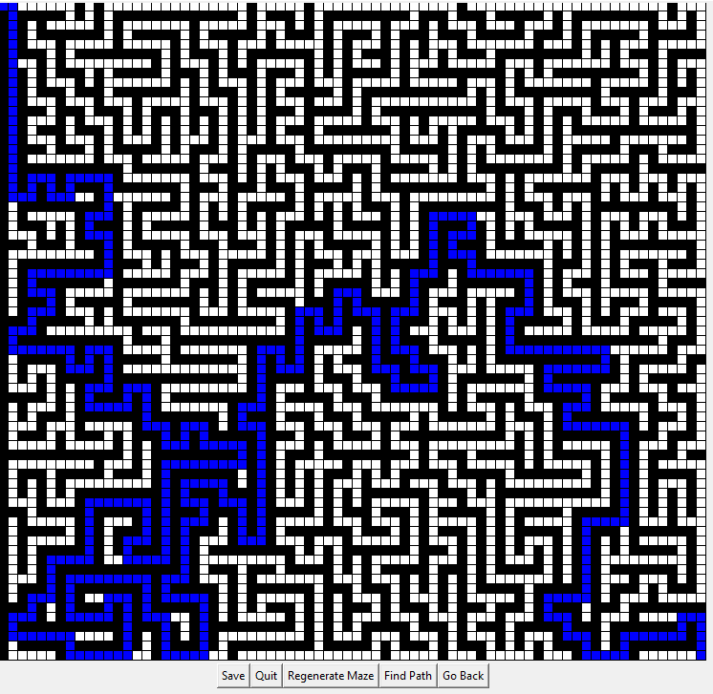

| Date | Test number | Purpose | How test is done | Expected results | Actual results | Next step |
| --- | --- | --- | --- | --- | --- | --- |
| 16 Nov 2023 | 139 | Test if the generate maze functionality still works and allows me to generate a maze after I’ve completely re-structured my code | Running the program → Logging in with valid username and password → Make maze → Generate maze → Find path | It should correctly generate the maze and when I click on “Find path” it should show me the path from the top left cell to the bottom right cell in blue | **SUCCESS**. As expected, the maze is correctly generated and clicking on “find path” highlights the path from the top left cell to the bottom right cell in blue | Test if I can still save the maze and if the maze saving functionality still works as expected. |

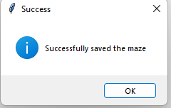

| Date | Test number | Purpose | How test is done | Expected results | Actual results | Next step |
| --- | --- | --- | --- | --- | --- | --- |
| 16 Nov 2023 | 140 | Test if the save mazes functionality works correctly and allows me to save mazes to the database | Running the program →Logging in with valid user credentials → Make maze → Generate maze → Save | It should save the maze and output an information dialog telling me that the maze has been saved | **SUCCESS**. It outputs the information dialogue correctly and lets me know that the maze was saved successfully | Test if the saved mazes menu works and displays the maze I had just saved |

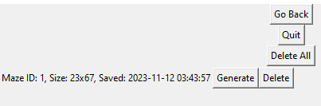

| Date | Test number | Purpose | How test is done | Expected results | Actual results | Next step |
| --- | --- | --- | --- | --- | --- | --- |
| 16 Nov 2023 | 141 | Test if my mazes menu works correctly and all the components of it also work, such as the ability to regenerate the same exact maze again and also the ability to delete individual mazes, as well as the ability to delete all mazes and the go back button | Running the program → Logging in with valid user credentials → My mazes → Delete → Generate → Delete all → No → Delete all → Yes → Go back → My mazes → Quit | All the components of the saved mazes menu should work. It should allow me to generate the maze and delete individual mazes. It should also allow me to delete all mazes and open a confirmation window. If I press “no” in the confirmation window it should close the confirmation window without further action. If I choose “delete all” button again and click on “yes” it should delete all the mazes from the database. The “Go back” button should allow me to go back to the main menu. “Quit” button should halt the program | **SUCCESS**, all the components of the saved mazes menu work. It allows me to generate the maze and delete individual mazes. It also allows me to delete all mazes and open a confirmation window. If I press “no” in the confirmation window it closes the confirmation window without further action. If I choose the “delete all” button again and click on “yes” it deletes all the mazes from the database. The “Go back” button allows me to go back to the main menu. “Quit” button halts the program. | Make it so that the user can’t create more than 1 signup window, currently the user can create an unlimited number of sign up windows, but only the most recent one will work. |

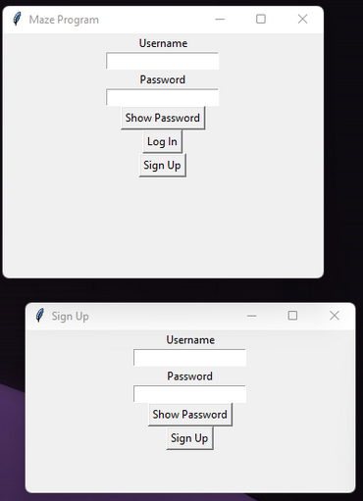

| Date | Test number | Purpose | How test is done | Expected results | Actual results | Next step |
| --- | --- | --- | --- | --- | --- | --- |
| 23 Dec 2023 | 142 | Test if we can create more than 1 signup window after one sign up window has already been created | Running the program → Sign up → Sign up → Sign up... | We should be able to create one sign up window, after that the “Sign Up” button should stop working | **SUCCESS**. As expected, when we sign up once, the sign up button doesn’t do anything after that | Add limits to what kind of characters can be input into the program, the username and password fields for login and signup should only accept characters a-z, A-Z, 0-9, -, _ |

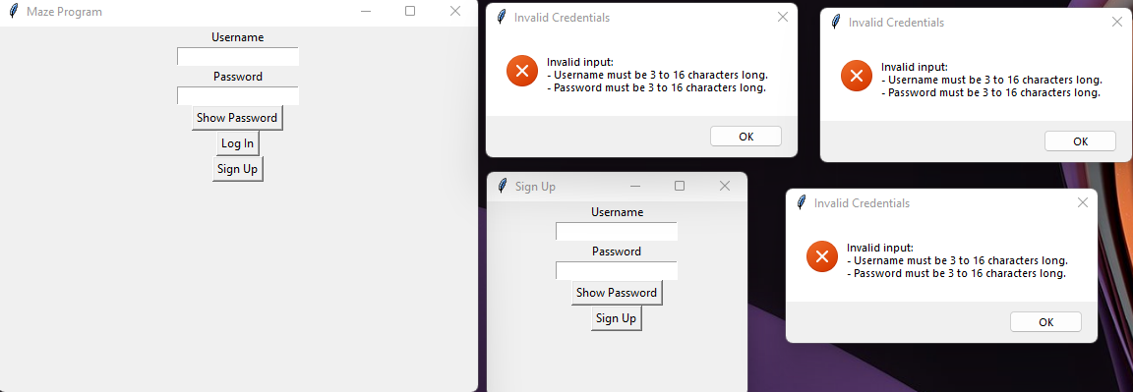

| Date | Test number | Purpose | How test is done | Expected results | Actual results | Next step |
| --- | --- | --- | --- | --- | --- | --- |
| 23 Dec 2023 | 143 | Test if the limits I added to the program work correctly. When the username and the password is less than 3 characters, it should output a single error dialog. When I click on sign up again it should close the previous error dialog and open a new one. | Running the program → Sign up → Sign up → Sign up → Sign up | It should open an error dialog informing me that I have invalid input, that my password is too short and my username is too short | **FAIL**. While it does actually tell me that my username and password are too short, it doesn’t close the previous error dialog when I have a new one open. | Change the program so that when the user clicks on “Sign up” again and it is invalid, it should close the previous “Invalid Credentials” window automatically to not allow more than 1 of the same window |

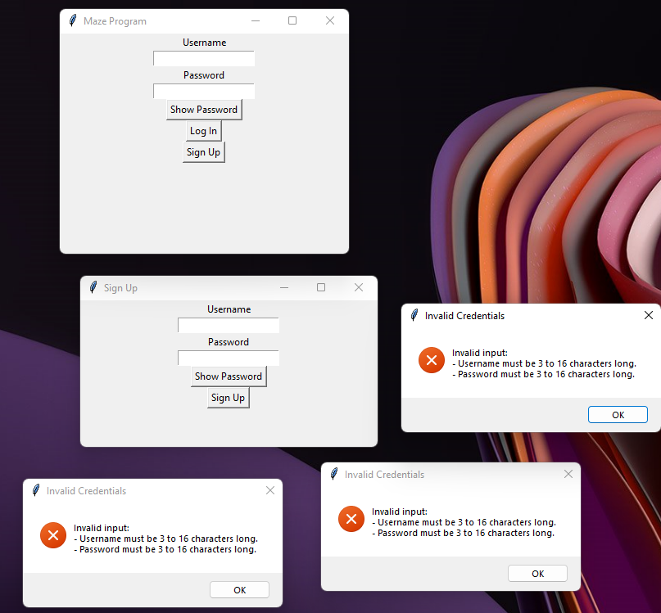

| Date | Test number | Purpose | How test is done | Expected results | Actual results | Next step |
| --- | --- | --- | --- | --- | --- | --- |
| 23 Dec 2023 | 144 | Test if multiple error dialogs are still created | Running the program → Sign up → Sign up → Sign up | At first, only one error dialog should open when I sign up without entering anything. Then, when I sign up again with invalid credentials, the error dialog previously should be destroyed | **FAIL**. The program doesn’t destroy past error dialogs, only creates new ones when I repeatedly fail to input the correct credentials that would be accepted by the program | Use a custom error dialog instead of windows’ error dialog to fix the issue |

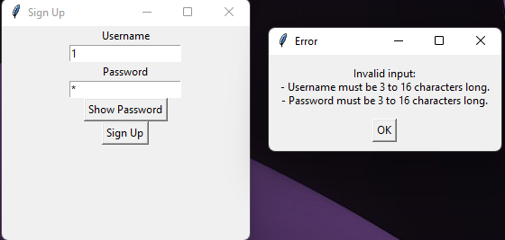

| Date | Test number | Purpose | How test is done | Expected results | Actual results | Next step |
| --- | --- | --- | --- | --- | --- | --- |
| 23 Dec 2023 | 145 | Test if multiple error dialogs can still be created when signing up with invalid user credentials | Running the program → Sign up → Sign up → Sign up | A new, custom error dialog should now be output instead of the windows 11’s default one. It should not be able to be created multiple times, when I click on “Sign up” again it should simply remove the old dialog and create a new one. | **SUCCESS**. As expected, the old error dialog is replaced and there can not be more than 1 error dialog. | Test all the edge cases for the username sign up, whether it is allowed to use invalid characters, whether the user can have a username that is too long or too short |

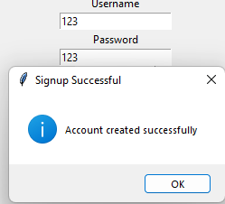

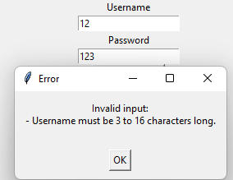

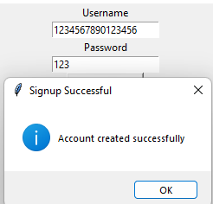

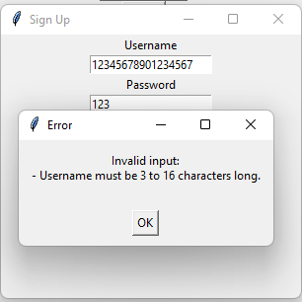

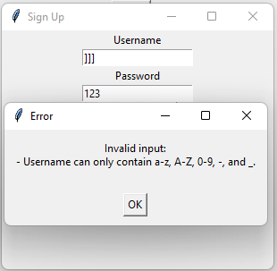

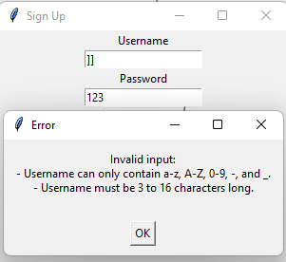

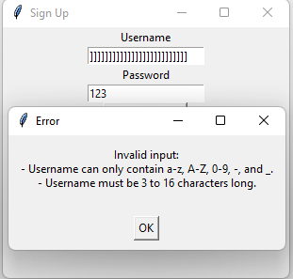

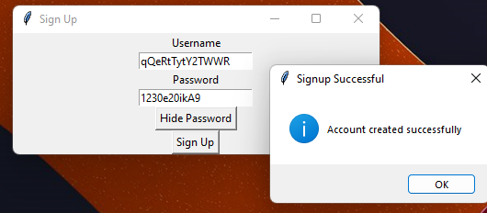

| Date | Test number | Purpose | How test is done | Expected results | Actual results | Next step |
| --- | --- | --- | --- | --- | --- | --- |
| 23 Dec 2023 | 146 | Test if the limits of the characters specified being a-z, A-Z, 0-9, -, _ and the username being from 3 to 16 characters work and don’t allow user to sign up with that | Running the program → Sign up → Testing with 3 characters for username → Testing with 2 characters for username → Testing for 16 characters for username → Testing for 17 characters for username  → Testing for non-alphanumeric characters (“]”)  → Testing where both cases fail for username and username is too short → Testing where both cases fail for username and username is too long → testing a large variety of characters | An error message should pop up telling the user what is wrong with their username, for example if it is outside the length bounds it should tell them that the username can only be 3-16 characters, if non-supported characters are used then it should tell them that the username can only be a-z, A-Z, 0-9, -, _ | **SUCCESS**. All the tests fail and an error dialog opens telling the user why their username does not pass. | Test if the limits of the characters specified being a-z, A-Z, 0-9, -, _ and the password being from 3 to 16 characters work and don’t allow user to sign up with that |

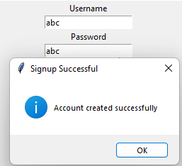

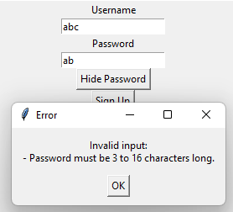

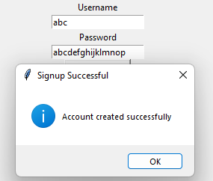

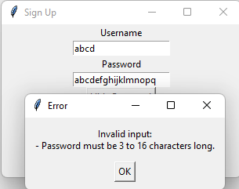

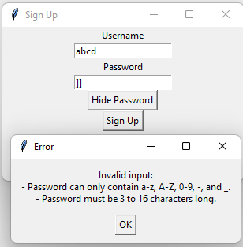

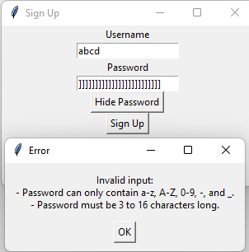

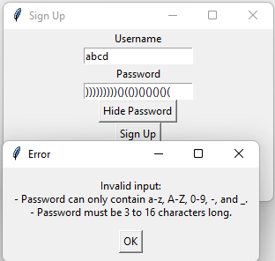

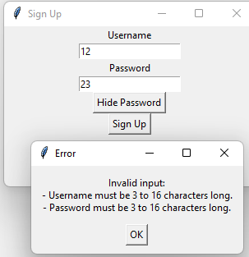

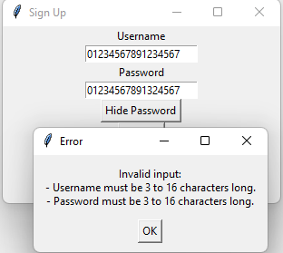

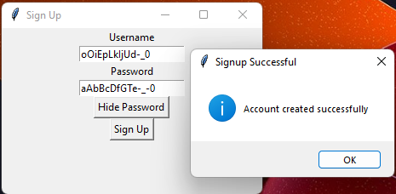

| Date | Test number | Purpose | How test is done | Expected results | Actual results | Next step |
| --- | --- | --- | --- | --- | --- | --- |
| 23 Dec 2023 | 147 | Test if the limits of the characters specified being a-z, A-Z, 0-9, -, _ and the password being from 3 to 16 characters work and don’t allow user to sign up with that | Running the program → Sign up → Testing with 3 characters for password→ Testing with 2 characters for password→ Testing for 16 characters for password→ Testing for 17 characters for password  → Testing for non-alphanumeric characters (“]”)  → Testing where both cases fail for password is too short → Testing where both cases fail for password and password is too long → Testing a large variety of characters for password | An error message should pop up telling the user what is wrong with their password, for example if it is outside the length bounds it should tell them that the password can only be 3-16 characters, if non-supported characters are used then it should tell them that the password can only be a-z, A-Z, 0-9, -, _ | **SUCCESS**. All the tests fail and an error dialog opens telling the user why their password does not pass. | - |